Good practice in primary mathematics: evidence from 20 successful schools
Age group: 3-11
Published: November 2011
Reference no: 110140

Contents
Introduction 4
Background information 5
Key findings 6
When are pupils taught formal methods for column addition, column subtraction, long multiplication and long division? 7
What do schools do to secure successful progression to column addition and subtraction? 9
The use of number lines and partitioning 11
What do schools do to secure successful progression to the formal algorithms for long multiplication and division? 14
The importance of inverse operations 18
Problem solving at the heart of learning arithmetic 20
Pupils’ preferred approaches and their fluency in calculating 24
What difficulties do pupils experience and how do
schools overcome them? 26
The role of technology and visual images 28
Calculation policies 30
Subject expertise and continuing professional development 31
Working with parents/carers 32
Notes 33
Further information 34
Publications by Ofsted 34
The Primary National Strategy 34
The Mathematics Specialist Teacher programme 34
Trends in international mathematics and science study (TIMSS) 34
Cognitive Acceleration in Mathematics Education (CAME) 34
Annex A: Schools visited 35

Introduction
Mathematics is all around us; it underpins much of our daily lives and our futures as individuals and collectively. As the Secretary of State for Education said last year:
‘… mathematical understanding is critical to our children's future. Our economic future depends on stimulating innovation, developing technological breakthroughs, making connections between scientific disciplines. And none of that is possible without ensuring more and more of our young people are mathematically literate and mathematically confident. Mathematical understanding underpins science and engineering, and it is the foundation of technological and economic progress. As information technology, computer science, modelling and simulation become integral to an ever-increasing group of industries, the importance of maths grows and grows.’
It is therefore of fundamental importance to ensure that children have the best possible grounding in mathematics during their primary years. Number, or arithmetic, is a key component of this. Public perceptions of arithmetic often relate to the ability to calculate quickly and accurately – to add, subtract, multiply and divide, both mentally and using traditional written methods. But arithmetic taught well gives children so much more than this. Understanding about number, its structures and relationships, underpins progression from counting in nursery rhymes to calculating with and reasoning about numbers of all sizes, to working with measures, and establishing the foundations for algebraic thinking. These grow into the skills so valued by the world of industry and higher education, and are the best starting points for equipping children for their future lives.
Criticism of learners’ skills in number regularly hit the headlines, especially at the points of transition to the next phase of education or work – ages 11, 16, 18 and beyond. Even those who have achieved the nationally expected levels of performance, such as Level 4 at age 11 or GCSE grade C at age 16, are criticised for not being able to use mathematics effectively. Far fewer column inches are given to celebration of those who can, but that is not a recent phenomenon.
The National Numeracy Strategy, introduced in 1999, provided detailed guidance on the teaching of mathematics through daily lessons in Key Stages 1 and 2 and promoted whole-class interactive teaching. The Strategy’s primary framework and supporting materials have been widely adopted by maintained primary schools. The aim with calculation was to teach a series of mental and informal methods to develop pupils’ grasp of number and flexibility in approaches, before moving on to more efficient traditional ways of setting the calculations out.
The Coalition Government has initiated a review of the National Curriculum, taking into account the curricula of high performing countries in mathematics, many of which focus strongly on conceptual understanding of number. The importance of teaching: the Schools White Paper, 2010, emphasises the importance of good teaching in mathematics, especially in primary schools, and for pupils’ essential grasp of the core mathematical processes and arithmetical functions.
This report examines the work of a sample of 10 maintained and 10 independent schools, all of which have strong track records of high achievement in mathematics. It focuses on identifying characteristics of effective practice in building pupils’ secure knowledge, skills and understanding of number so that they demonstrate fluency in calculating, solving problems and reasoning about number. The report also looks at the choices of methods pupils make when presented with calculations and problems to solve. Some key common factors emerge, which might be more widely replicated, as well as some differences between the schools.

Background information
This survey was conducted following a ministerial request for Ofsted to provide evidence on effective practice in the teaching of early arithmetic. All of the schools visited are successful institutions, as reflected in their most recent inspection reports. While many other highly effective schools might have been visited, the 20 schools selected for the survey span a wide range of contextual characteristics, such as size and location, as well as being educationally diverse due to their maintained or independent status and varying attainment on entry to the school. Results of national Key Stage 2 mathematics tests (taken at age 11, Year 6) for the maintained schools, show their pupils’ progress has been significantly above the national average, and often outstanding, for at least the last four consecutive years.
The following four examples illustrate the traditional vertical English algorithms for addition, subtraction, long multiplication and long division referred to in this report. (Note: many other European countries do not set calculations out in the same way.)

Figure 1: Examples of the traditional algorithms for addition, subtraction, multiplication and division.
Column addition | Column subtraction |  | Long multiplication |  | Long division
567  + 226  793  ¹ |  | 3⁵6¹2  - 2 2 6  1 3 6  3 6¹2  Or very occasionally  – 2 2₁6  1 3 6 |  | 2 4 8  x 3 4  7₁4₂4 0  These two lines  in either order  + 9₁9₃2  8 4 3 2  ¹ ¹ |  | __2 4  16 ) 38⁶4  – 32 ↓  64  – 64  0

Key findings
The following key findings, taken together, reflect the ‘what’ and ‘how’ that underpin effective learning through which pupils become fluent in calculating, solving problems and reasoning about number.
- Practical, hands-on experiences of using, comparing and calculating with numbers and quantities and the development of mental methods are of crucial importance in establishing the best mathematical start in the Early Years Foundation Stage and Key Stage 1. The schools visited couple this with plenty of opportunities for developing mathematical language so that pupils learn to express their thinking using the correct vocabulary.
- Understanding of place value, fluency in mental methods, and good recall of number facts such as multiplication tables and number bonds are considered by the schools to be essential precursors for learning traditional vertical algorithms (methods) for addition, subtraction, multiplication and division.
- Subtraction is generally introduced alongside its inverse operation, addition, and division alongside its inverse, multiplication. Pupils’ fluency and understanding of this concept of inverse operations are aided by practice in rewriting ‘number sentences’ like 3 + 5 = 8 as 8 – 3 = 5 and 8 – 5 = 3 and solving ‘missing number’ questions like – 4 = 5 by thinking 5 + 4 = 9 or 9 – 4 = 5.
- High-quality teaching secures pupils’ understanding of structure and relationships in number, for instance place value and the effect of multiplying or dividing by 10, and progress in developing increasingly sophisticated mental and written methods.
- In lessons and in interviews with inspectors, pupils often chose the traditional algorithms over other methods. When encouraged, most showed flexibility in their thinking and approaches, enabling them to solve a variety of problems as well as calculate accurately.
- Pupils’ confidence, fluency and versatility are nurtured through a strong emphasis on problem solving as an integral part of learning within each topic. Skills in calculation are strengthened through solving a wide range of problems, exploiting links with work on measures and data handling, and meaningful application to cross-curricular themes and work in other subjects.
- The schools are quick to recognise and intervene in a focused way when pupils encounter difficulties. This ensures misconceptions do not impede the next steps in learning.
- Many of the schools have reduced the use of ‘expanded methods’ and ‘chunking’ in moving towards efficient methods because they find that too many steps in methods confuse pupils, especially the less able. Several of the schools do not teach the traditional long division algorithm by the end of Year 6 (age 11) and most of those that do say that a large proportion of pupils do not become fluent in it.
- A feature of strong practice in the maintained schools is their clear, coherent calculation policies and guidance, which are tailored to the particular school’s context. They ensure consistent approaches and use of visual images and models that secure progression in pupils’ skills and knowledge lesson by lesson and year by year.
- These schools recognise the importance of good subject knowledge and subject-specific teaching skills and seek to enhance these aspects of subject expertise. Some of the schools benefit from senior or subject leaders who have high levels of mathematical expertise. Several schools adopt whole-school approaches to developing the subject expertise of teachers and teaching assistants. This supports effective planning, teaching and intervention. Most of the larger independent preparatory schools provide specialist mathematics teaching from Year 4 or 5 onwards.

When are pupils taught formal methods for column addition, column subtraction, long multiplication and long division?
- The National Curriculum does not specify when or whether these algorithms should be taught. The descriptor for performance at Level 5 includes the statement that ‘pupils should be able to multiply and divide a three-digit number by a two-digit number’ and questions on these appear regularly on Key Stage 2 test papers. The Primary National Strategy framework encourages increasing efficiency of methods of calculation for all four operations as pupils progress through the primary years. Some independent schools also make use of Key Stage 2 tests and some focus on Common Entrance Examinations, mainly at age 13. This means there are some significant differences between maintained and some independent schools in the timing and nature of key assessments and the mathematics curricula they assess. A few of the independent schools visited explained that they feel no pressures from Key Stage 2 tests or Common Entrance Examinations because their pupils transfer directly to independent senior schools.
- Most of the schools in the survey teach column addition and subtraction in lower Key Stage 2, with most of the maintained schools favouring Year 4 and the independent schools Year 3, although around half of the schools introduce them earlier for higher attaining pupils or later for lower attaining pupils. The difference between the two sectors relates, in part, to pupils’ transition at age eight between independent pre-preparatory and preparatory schools. Three schools, one maintained and two independent, introduce column addition and subtraction in Key Stage 1. However, these schools’ approaches vary, particularly in the emphasis they place on the use of practical apparatus, visual images and place value. One school moves directly into teaching formal algorithms and, while their pupils calculated accurately, they lacked the flexibility shown by pupils from other schools in solving number problems.
- All of the schools teach long multiplication in upper Key Stage 2, usually Year 5, often having introduced it first through the ‘grid method’. Teachers usually enable pupils to see how the two forms of recording align before moving to the more efficient method; for example, 246 x 37.
The grid method | The formal algorithm

 |  |  |  |  |  | 246
x | 200 | 40 | 6 |  |  | x 37
30 | 6000 | 1200 | 180 | 6000+1200+180 = 7380 | → | 7380
7 | 1400 | 280 | 42 | 1400+280+42 = 1722 | → | 1722
 |  |  |  | Answer 246x37 = 9102 |  | 9102
- One of the advantages of learning the grid method is that it can be used later for work on multiplying decimals, and for secondary mathematics topics including multiplication of algebraic expressions such as (2x + 3)(x – 6) and numerical expressions involving square roots, for example (√3 – 1)(2√3 + 1). It is particularly valuable in emphasising the four products, thereby tackling the common error where only the first and last terms in each bracket are multiplied. Moreover, while able pupils can often move to more succinct methods of expanding and simplifying such products, this method of recording is accessible to middle-attaining secondary pupils. It also provides insight into the reverse process, factorisation, which pupils generally find more difficult.
- The schools were confident that the large majority of their pupils become proficient in using the formal algorithms for addition, subtraction and multiplication but most said that division is a different story. While all of the maintained schools teach their pupils to divide three-digit numbers by two-digit numbers, many expressed concern that their pupils were not confident in performing this calculation and unease about the effectiveness of the different methods, principally ‘chunking’, short division, and the traditional long division algorithm. Two of the nine maintained schools with Key Stage 2 pupils do not teach the traditional algorithm at all; two teach it to high attaining pupils only; and the rest teach it to all or most of their Year 6 pupils but know that many are insecure in its use.
- Practice in the 10 independent schools varies widely, in part because most have pupils to age 13 or beyond. Six of the schools choose not to teach the long division algorithm by the age of 11. Three of these explained that they wait to teach it in Year 7, when they consider that pupils are more ready. The four remaining schools, one of which is selective and another has pupils to age 11 only, elect to teach it in Years 5 or 6, as in the maintained schools.

What do schools do to secure successful progression to column addition and subtraction?
- The schools showed almost universal agreement on the essential foundations for pupils to be successful with all four arithmetic operations: a clear emphasis on practical, hands-on activities in the Early Years Foundation Stage and Key Stage 1, with a high profile given to developing mathematical language and mental mathematics.

Figure 2: Nursery children calculating with milk bottles and during a game of skittles.
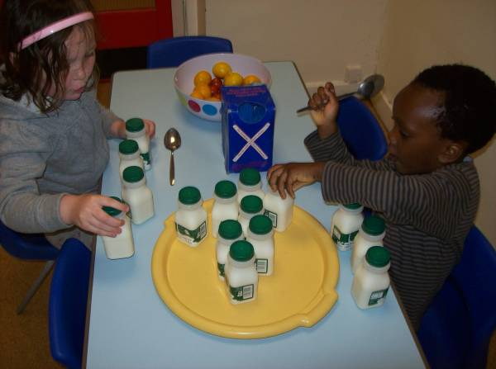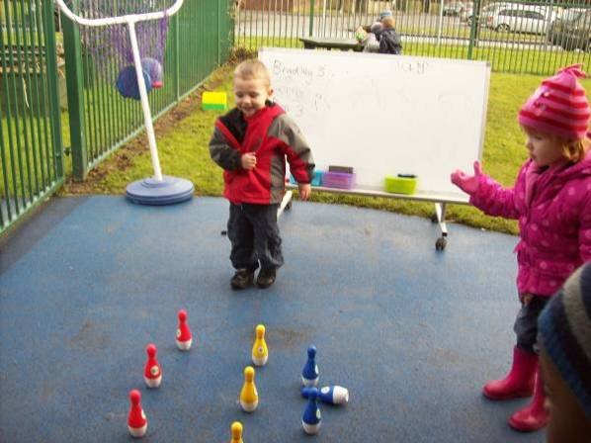

A mathematically rich Reception classroom
The teacher seizes every opportunity for children to use mathematics in everyday activities. Working out daily attendance and absences of boys and girls becomes a shared activity, which significantly improves children’s addition and subtraction skills. Similarly, every opportunity is taken to develop children's understanding and use of mathematical language.
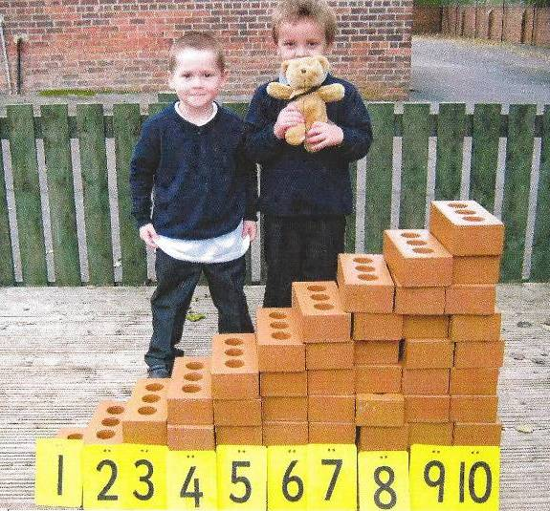
Mathematical games prove highly engaging as children cast dice, play matching card games, roll marbles into numbered compartments and use the computer to investigate patterns and number sequences. The stimulating outdoor environment
buzzes with activity as children organise races on foot and using wheeled vehicles, for which they receive rosettes to develop a clear understanding of ordinal numbers
(1st, 2nd, 3rd…). Other children construct stepped walls using building blocks, learning to count forward and back as they move soft toys from one step to another.
On special occasions, children are given £1 to spend at the local shop. With help from adults, they produce simple shopping lists to decide what they want to buy and what they can afford. This engagement in mathematics develops children's confidence, understanding and enjoyment of using mathematics in everyday life.
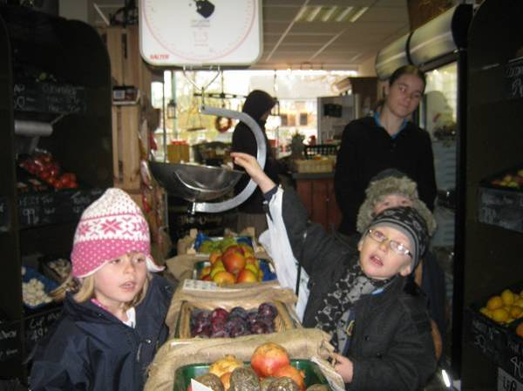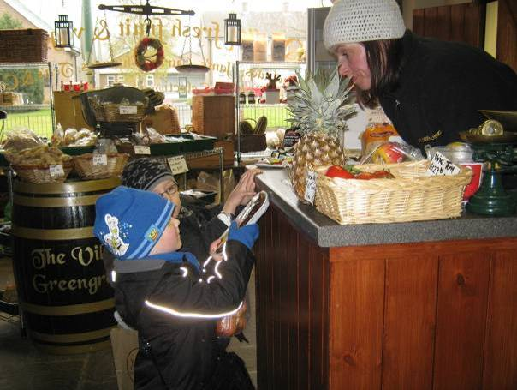
A good understanding of place value is considered to be of paramount importance. This is supported by a wide range of practical equipment including base-10 apparatus, 100 squares, bead strings, place-value cards and number lines. Because pupils also require good instant recall of number facts, such as number bonds to 10, and, later, multiplication tables, every opportunity is taken to develop these.
- Although the maintained schools base their planning on the Primary National Strategy framework, almost all have thought carefully about which interim methods to use, with several choosing to omit or reduce the emphasis on some, mainly because lower-attaining pupils become confused when presented with different approaches and higher-attaining pupils are able to move swiftly to more efficient methods. The independent schools visited make greater use of textbook schemes than the maintained schools. While many of these include the interim methods illustrated in the primary framework materials, the independent schools vary in the degree to which they incorporate them in teaching, sometimes preferring to move directly to standard algorithms.
- In the youngest classes, pupils’ experience of number is diverse, from songs, rhymes and mathematical games, to early calculations to solve problems; for instance learning to add two numbers through games or practical activities and sometimes recording their calculations as number sentences. Figure 3 shows Reception pupils in one school creating number sentences using large coloured discs, for example 2 + 3 = 5, with the more able children calculating and recording the number sentences independently.

Figure 3: Reception children constructing and recording number sentences
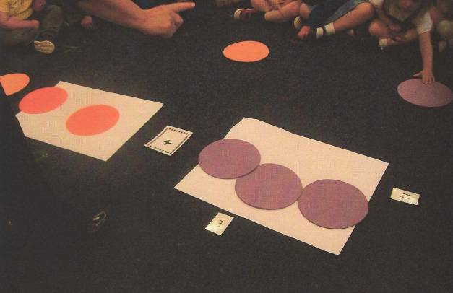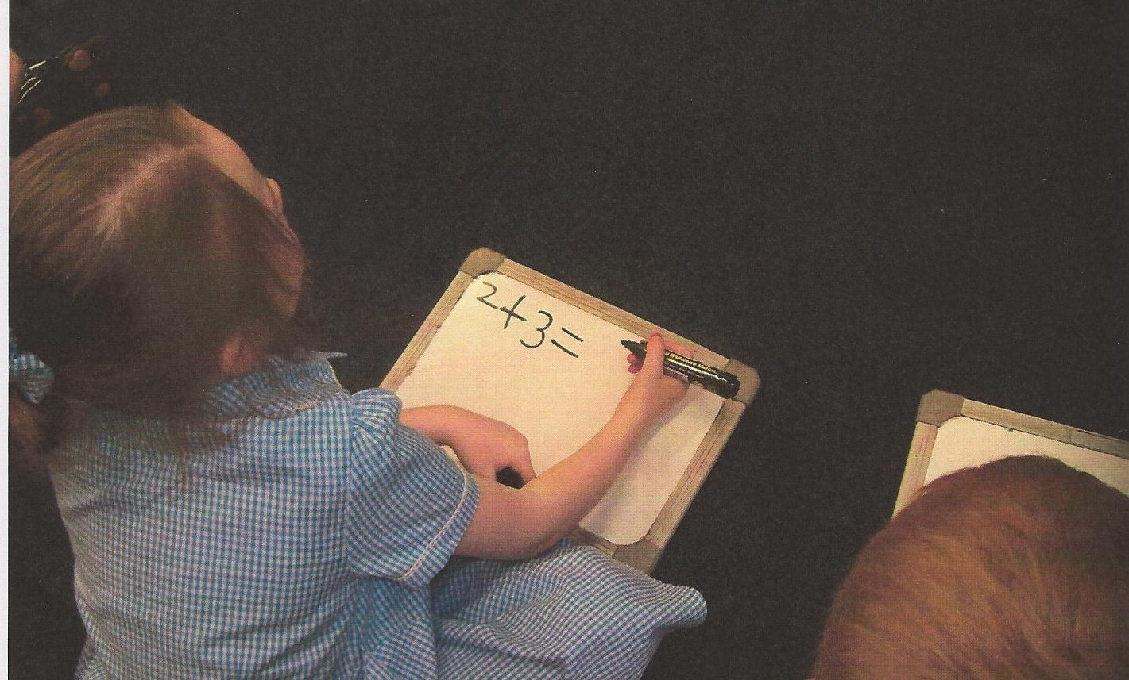
- At each stage in developing skills in addition, subtraction, multiplication and division, the schools follow a similar pattern in:
- establishing pre-requisite knowledge of the number system such as place value, families of number facts and partitioning
- calculating in practical contexts and using hands-on resources such as base-10 materials
- developing mental methods supported by jottings and visual images such as number lines
- establishing written forms of recording, moving towards more efficient methods over time.
- Most of the schools surveyed emphasised the importance of ensuring pupils are secure, for instance in place value, number facts and multiplication tables, and mental methods, before the next step is introduced.
- Once pupils have been introduced to a formal algorithm, the schools generally ensure that the skills are revisited the following year by extending to larger numbers, and to decimals. For example, with addition and subtraction, teachers introduce tens and units at first without, and then with, the need to ‘carry’ or ‘exchange’, before moving on to three-digit whole numbers (hundreds, tens and units). The following year, this is extended to thousands, hundreds, tens and units and to two places of decimals, which links with work on measures (money and length in particular). Throughout, pupils gain experience and practice through solving a wide range of problems, including handling statistical data.

The use of number lines and partitioning
- Almost all the schools visited consider fluent and versatile use of the number line as crucial in developing understanding from Key Stage 1 onwards of the concepts underpinning the four operations. Moreover, it provides an important image for mental calculations.
- The main purpose of partitioning numbers is to aid understanding of calculation, prior to the introduction of more formal and efficient methods; for example, 32 + 26 can be partitioned as 30 + 2 and 20 + 6, allowing the tens to be added (50) and the units (8), and then recombined to make 58. This models a sensible mental process for adding the numbers. It can also be linked to the process of column addition:
32 (30 + 2)
+ 26 (20 + 6)
58 (50 + 8)
- Work seen in pupils’ books and observed in some lessons during the survey shows teachers making deliberate connections between informal methods such as number lines and partitioning and formal column procedures, as seen in the example of a Year 3 pupil’s work shown in figure 4.
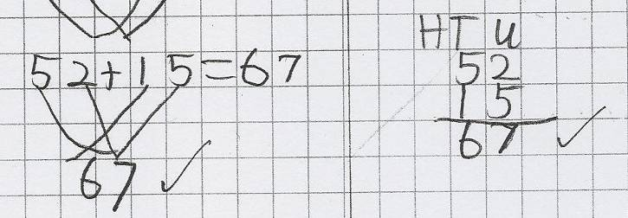

Figure 4: Relating mental methods to horizontal and vertical recording.

- While younger pupils often use partitioning into tens and units to add two-digit numbers accurately, they are sometimes less successful in subtracting, particularly when the second units digit is larger than the first, for example
43 – 27. Nationally, pupils have a similar difficulty when subtracting in columns, with 24 being a common incorrect answer to 43 – 27. Pupils rarely partition 43 as 30 + 13, which would allow 20 + 7 to be subtracted to give 10 + 6 = 16, mirroring the later method of column subtraction.
- Instead, the most successful strategy adopted by younger pupils was based on use of the number line, with counting on or back, for example, three places on from 27 to 30, ten places to 40, and another three to 43, making
3 + 10 + 3 = 16. In the survey, pupils were at different stages in developing their subtraction skills. Those who partitioned the second number only tended to be more successful in subtracting than those who partitioned both numbers because they counted on or back from a starting number. An advantage of partitioning the second number only is that the process of counting on or back works in the same way for addition and subtraction (see figure 5, pupil A). Partitioning both numbers into tens and units can lead to difficulties when pupils try to subtract the tens and units in the same way as they add. Careful consideration of consistency in the models used was reflected in some schools’ calculation policies and practice.
- Figure 5 (below) shows three examples of lower-middle ability Year 3 pupils’ calculations. In the first two pairs of illustrations, pupils calculate 35 + 17 and 35 – 17: notice that pupil B struggles to subtract 10 + 7 from 30 + 5, and initially writes 22 as the answer, while pupil A uses a number line accurately for both parts. In the third illustration, pupil C manages to evaluate 72 – 58 using vertical column subtraction but makes the same mistake as pupil B when using partitioning.

Figure 5: Middle to lower attaining Year 3 pupils’ subtraction calculations.
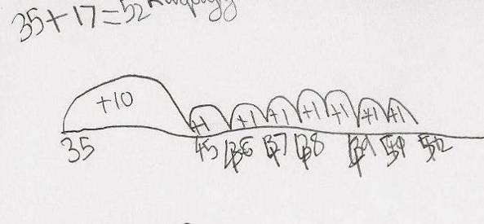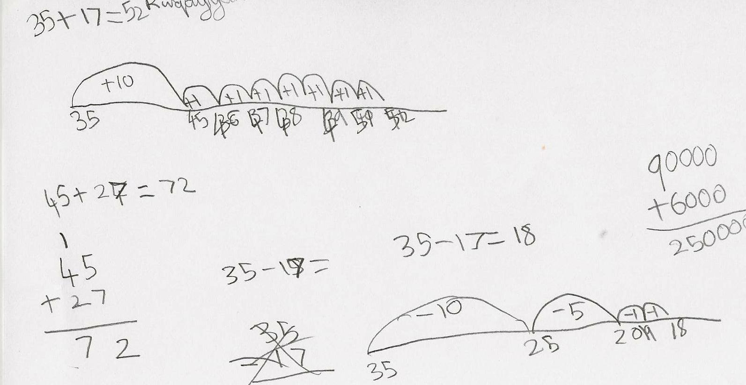
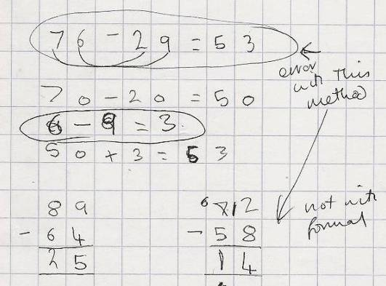
Pupil A
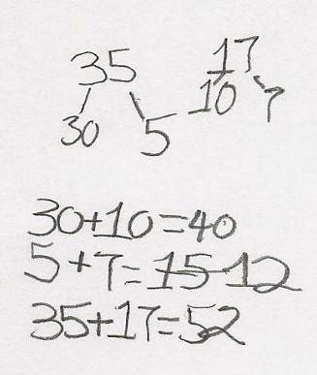

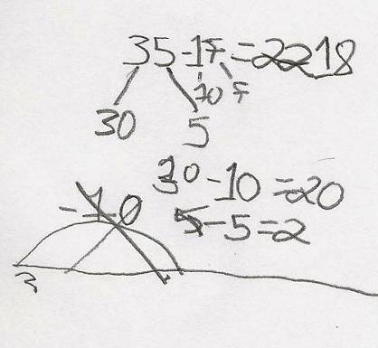

Pupil B Pupil C

- Overall, while the introduction of the column method for addition is sometimes linked explicitly to partitioning, no such link with partitioning or number lines for column subtraction was evident in pupils’ work and discussions with inspectors although it is included in Primary National Strategy guidance. Instead, in progressing from the use of the number line, the schools built effectively on pupils’ knowledge of place value and the concept of ‘exchange’ between one ten and ten units, initially using practical equipment, and reversing the process already learnt for addition. Pupils’ understanding and proficiency was strengthened by extending the method to gradually more complex numbers and through application to problem solving and other areas of mathematics such as measures and data handling. Once established, pupils used column subtraction confidently and accurately.

What do schools do to secure successful progression to the formal algorithms for long multiplication and division?
- The foundations for multiplication are also laid in the infant years. As with addition and subtraction, the schools emphasised practical, hands-on activities, with a high profile given to developing mathematical language and mental mathematics, coupled with visual images and physical representations of sharing, grouping, arrays and patterns.
- An aspect of multiplication that was less evident in pupils’ work is its use in scaling. In this illustration, taken from one school’s very good calculation policy, the longer ribbon is four times the length of the shorter ribbon.
5 cm 20 cm
- Work on similar figures in secondary mathematics is often impeded by pupils trying to use additive rather than multiplicative relationships. In the above example, for instance, they would tend to notice that the longer ribbon is 15 cm longer than the shorter ribbon rather than four times as long. Errors occur when pupils assume that other related quantities or measures obey the same additive rule. Work more broadly on proportionality is similarly adversely affected.
- As pupils progress through primary school, instant recall of tables and associated number facts and good understanding of place value become increasingly important. Without such crucial knowledge, pupils struggle to multiply accurately and quickly. Teachers in the schools visited included fluent recall of multiplication tables and multiplication of single-digit numbers by 10 and multiples of 10 as essential prerequisites to success in multiplication.
- Partitioning was widely used in the maintained schools visited to extend mental methods and introduce written methods for multiplication. By writing 46 x 3 as (40 + 6) x 3 and using the distributive law, the two products 40 x 3 = 120 and 6 x 3 = 18 can be found and summed to give 138. Some schools also introduce the ‘grid method’ for recording the calculations of each product in the partitioned number:
x | 40 | 6
3 | 120 | 18 | 120 + 18 = 138

- The schools visited vary in how quickly they move to writing such multiplication calculations in a vertical format but, however the calculations are recorded, all schools emphasise very clearly the products being calculated:
46
x ₁3
138 (3 x 6 = 18; 8 units and carry/exchange 10 units for 1 ten)
(3 x 4 tens plus the 1 carried ten = 13 tens)
- In one school, teachers use particularly inventive approaches to help pupils to understand the relationship between interim methods and formal algorithms. Pupils are asked to use both methods side-by-side, compare them and comment on any perceived advantages and disadvantages.
In a Year 4 lesson, the grid method for multiplication was taught alongside the vertical column method, which was new to the pupils. On the interactive whiteboard, the teacher provided a lucid illustration of the grid method for multiplying 28 x 6, which pupils recognised and were able to explain faultlessly. The teacher then transferred the same product to a vertical column method so that pupils could see the relationship between the two methods.
Grid method: x 20 8 Vertical method: 28
6 120 48 x 6
48 (6 x 8) 120 (6 x 20) 168
During the class discussion, pupils pointed out the similarities between the two methods. They noticed where the numbers 48 and 120 had been repositioned. One pupil commented that ‘the compact method is like partitioning in your head.’ The teacher progressed to multiplying a three-digit number (136 x 4), questioning pupils to ensure that they were fully engaged and understanding. This was followed by paired work using mini-whiteboards with one pupil using the grid method, the other using the vertical method, and then comparing answers. Once the teacher had checked that pupils were secure with the methods of multiplication, they were given further examples to develop, which were carefully differentiated to match pupils' levels of understanding. Later, pupils moved on to writing the vertical method in the usual compact way.
- Most schools use a grid method initially to show the six products involved in calculating a three-digit number by a two-digit number, but they then move on to the more efficient formal algorithm of ‘long multiplication’. By the end of
Year 5, almost all pupils in the maintained and independent schools visited have been taught the formal algorithm for long multiplication, with lower attaining pupils sometimes meeting it in Year 6 instead. Only one of the 20 schools visited chooses not to teach the formal algorithm.
- Schools do not generally use partitioning as a written method for division. Early division is sometimes linked to counting back in steps, for instance 15 ÷ 3 has five steps of size 3. This technique is known as ‘chunking’ which can be useful for dividing mentally. While efficient chunking of larger numbers resembles long division, for example 384 ÷ 16, the mathematical reasoning is different because chunking considers the whole number being divided (the ‘dividend’), while the algorithm starts with the most significant figures in the dividend. For instance in the example below, chunking concentrates initially on 384 while long division divides 16 into 38.
Chunking |  | Long division | (thinking not generally recorded)
__24 |  | __24
16 ) 384 |  | 16 ) 38⁶4 | (38÷16=2 r 6; 2x16=32)
– 320 (20x16) |  | – 32 ↓ | (bring the 4 down)
64 |  | 64 | (16 into 64=4; 4x16=64)
– 64 (4x16) |  | – 64
0 |  | 0 | (no remainder)

- However, as many of the schools reported, pupils find efficient chunking difficult. Because they do not spot the larger multiples of the divisor, they tend to work repeatedly in smaller steps of 10 times and 1 times the divisor. In the above example, this would typically create six separate subtractions (160, then 160 again, followed by four 16s) rather than the two subtractions illustrated above. Such an approach often leads to errors. A further issue is that the mathematical thinking behind the method of short division, which most pupils master, is different from the thinking behind ‘chunking’; one method does not lead into or support the other. Moreover, the chunking approach is not easily extended to division of decimals.
- Nearly half of the schools in the survey do not teach ‘chunking’ as a strategy for division. They explained that it confuses pupils, particularly those who are low attaining. Instead, many of the schools use short division supported by jottings, such as the first few numbers in the multiplication table of the divisor. For example:
__ 2 4 | 16 (the first few multiples of 16)
16 ) 3 8 ⁶4 | 32
 | 48
 | 64

- Figure 6 below shows an extract from a Year 6 pupil’s book where short division of whole numbers is extended to two-digit divisors and decimal dividends. The same method is used throughout, with jottings to support the last question.

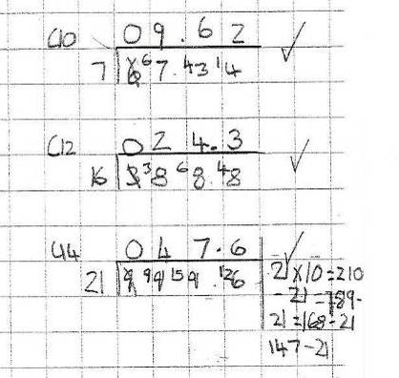
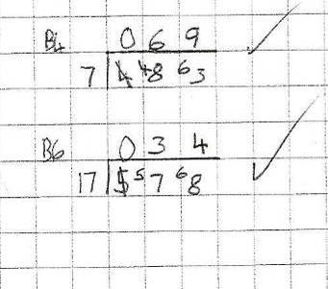
Figure 6: Use of short division and its extension to decimals.

- In one independent school, which does not teach the long division algorithm, pupils learn to factorise the divisor and then divide by the factors, so 8 and 2, or 4 twice in the example 432 ÷ 16 below. They do this well (see figure 7). If the divisor is a prime number, the pupils use the short division method illustrated above.

Figure 7: Alternative approaches taken by Year 6 pupils to calculate 432 ÷ 8 and 432 ÷ 16.
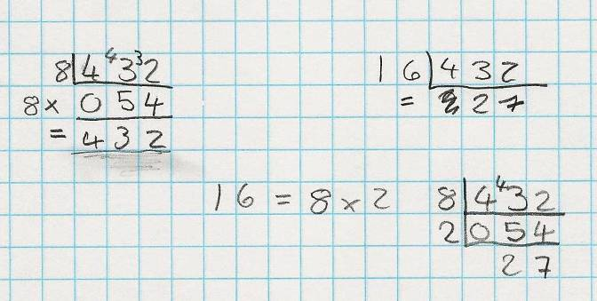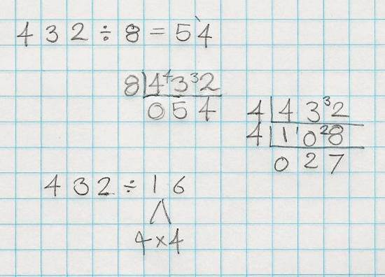
Pupil A Pupil B
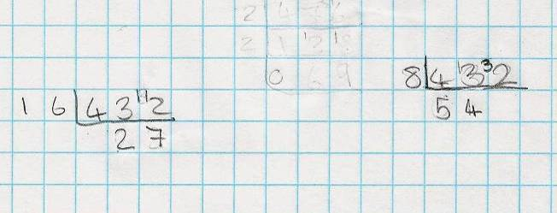
Pupil C

- Note that pupil A checks his answer to 432 ÷ 8 by multiplying 54 by 8. To calculate 432 ÷ 16, pupils A and B factorise 16 into 8 x 2 and 4 x 4 respectively and then divide successively by the two factors, while pupil C divides 432 directly by 16. All three pupils carried out the calculations quickly and accurately and, in discussion with the inspector, showed understanding of the connection between the two calculations.
- As with addition and subtraction, once pupils have been introduced to a formal algorithm, the schools develop pupils’ fluency through work on measures, statistics and by solving a wide range of problems. This enables pupils to strengthen their growing repertoire of knowledge and reasoning skills through application, to continuously synthesise and deepen their understanding of mathematics, and to develop independence.

The importance of inverse operations
- The schools generally introduced subtraction at broadly the same time as addition, and division together with multiplication, enabling pupils to see the links between the pairs of operations. However, they varied in how much emphasis they placed on pupils using the inverse operations from their introduction and the age at which pupils started using the term ‘inverse’.

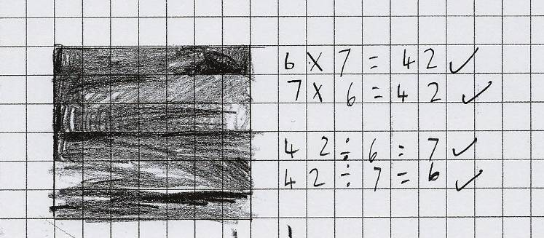
Figure 8: A Year 3 pupil’s
illustration of a 6 x 7 array,
showing commutative and
inverse relationships.

- While the levels of competency and accuracy in using the four operations were high in all of the schools, one of the experiences common to those pupils who demonstrated the greatest fluency with number was the many and varied opportunities they had had to use inverses in ‘missing number’ problems, in creating equivalent calculations/number sentences, and as a mechanism for checking their answers.
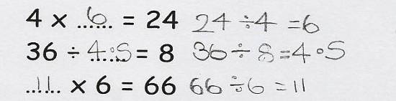
Figure 9: A pupil using inverse operations to calculate missing numbers.

- The following example shows how inverse operations were developed very effectively in a Year 3 lesson.
In the main part of the lesson, the pupils worked in four groups creating as many calculations with the answer 20 as possible. Each group had five minutes to work on one operation before they moved round to the next table and operation. This stimulated great excitement and much discussion. Pupils recorded the calculations on large sheets of paper, with each new group adding to what the previous groups had written so that the task became progressively more difficult.
During this activity, pupils showed good understanding of number. Their comments included, ‘You can swap multiply and add sums around, like 5 + 15 and 15 + 5, but not subtract and divide; 2 – 1 = 1 but 1 – 2 = -1’ and ‘Subtracting is easy because you can start with any number bigger than 20; 3000 – 2980 = 20’.
As the task progressed, a few errors appeared with multiplication. One pupil wrote 0 x 20 = 20 but subsequent discussion led to pupils identifying that this was incorrect; as one pupil put it, ‘no 20s are 0’. The pupils did not spot that 2x2x2x2x2x2x2x2x2x2 was incorrect. (The teacher planned to look in detail at the sheets before the next lesson to tackle any errors and misconceptions.)
The teacher supported low-attaining pupils working at the ‘division table’. Having established 20 x 2 = 40, she asked them to recall a ‘posh word’ they had met in the previous day’s lesson. One girl suggested ‘inverse’ and went on to say 40 ÷ 20 = 2. The teacher reminded her that they were looking to make 20, and 40 ÷ 2 = 20 was quickly offered. Starting next with 20 x 10 = 200, this group of pupils soon generated several divisions with answers 20, showing a good grasp of related number facts.
In the plenary, the teacher asked pupils to insert missing operations into calculations, and to explain their reasoning. For 18 … 4 = 14, pupils quickly ruled out + and x as ‘the answer would be bigger than 18’. Eliminating ÷ proved more difficult but halving 18 to get 9 eventually ruled it out. All were satisfied with 18 – 4. With 5 … 3 = 15, pupils quickly suggested x. When the teacher asked, ‘Could we have used an inverse to help us?’ the pupils replied promptly ‘15 ÷ 3 = 5’.
- Teachers make the connection between repeated addition and multiplication in developing pupils’ understanding of arrays and then multiplication but, once the concept is secure, this link is sensibly not generally revisited. In discussions with inspectors, pupils rarely used repeated addition to calculate answers to products. Moreover, the images and practical apparatus used to support early multiplication readily show it is commutative (see figure 10) and pupils become fluent in using this concept at an early stage. They also recognise that division does not work in the same way, that 15 ÷ 5 has a different meaning to 5 ÷ 15.

Figure 10: The product of 8 and 4 shown as an array. It is clear that the four rows of eight and eight columns of four are equivalent.
8 x 4 = 32

4 x 8 = 32

- In the same way that repeated addition links to multiplication, counting back on a number line, say from 18 in threes, shows how many groups of three can be found. Similarly, 18 items can be placed in groups of three. However, 18 can also be shared between three people, with each receiving 6 items. Thus
18 ÷ 3 = 6 is different from 18 ÷ 6 = 3. So, although 3 x 6 and 6 x 3 both equal 18, the meanings of 18 ÷ 3 and 18 ÷ 6 are different. An everyday example is 18 eggs in three boxes, each box containing six eggs: 18 eggs ÷ 6 eggs gives the number of boxes (3), whereas 18 eggs ÷ 3 boxes gives the number of eggs to a box (6). For one multiplication fact there are two associated division facts.
- As mentioned previously, division by ‘chunking’ is based on the idea of repeated subtraction, when multiples of the divisor are subtracted. It is a rather cumbersome method when written down but can be a useful mental strategy for division of numbers that are larger than those found in the multiplication tables, For example, 81 ÷ 3: knowing that 10 threes are 30 and 20 threes are 60 leaves only 21 to be divided by 3, which is 7. In total, 27 threes make 81, and hence 81 ÷ 3 is 27. Chunking, even done efficiently, does not lead directly to the answer in the way that the algorithms for short and long division do.

Problem solving at the heart of learning arithmetic
- The emphasis almost all of the schools placed on pupils using and applying their arithmetic skills to solving a wide range of problems was striking. Diverse opportunities were provided within mathematics, including measures and data handling, and through thematic and cross-curricular work. Pupils’ extensive experience of solving problems deepens their understanding and increases their fluency and sense of number.
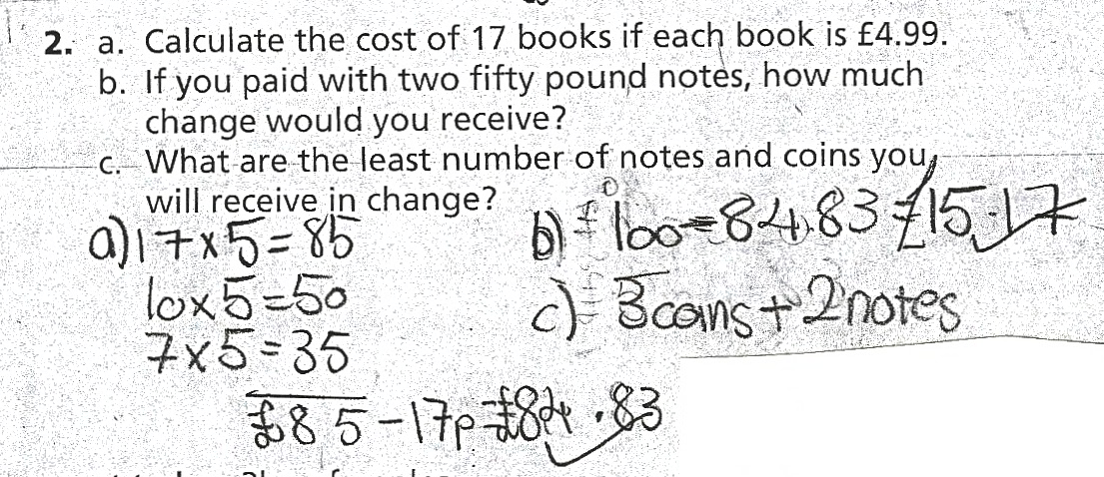
- Problem-solving and cross-curricular use of mathematics were regular and integral to pupils’ learning of mathematics, and diverse in nature. A small selection of examples of pupils’ work is shown below.

Figure 11: A money problem that invites alternative approaches. This pupil has calculated 17 x £5 and subtracted 17 pence to find 17 x £4.99.

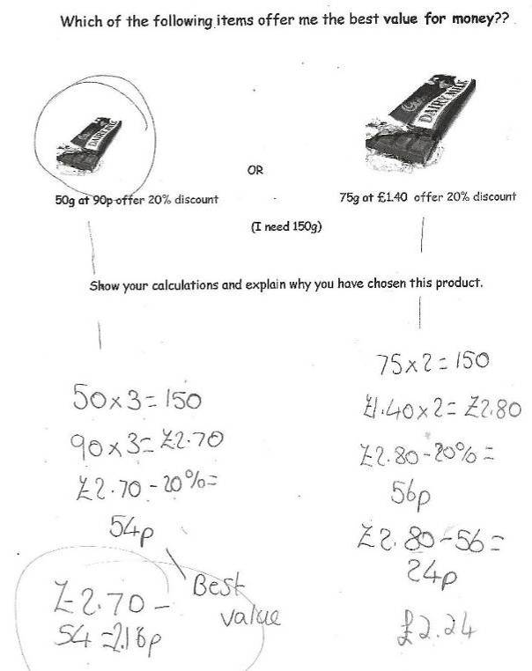
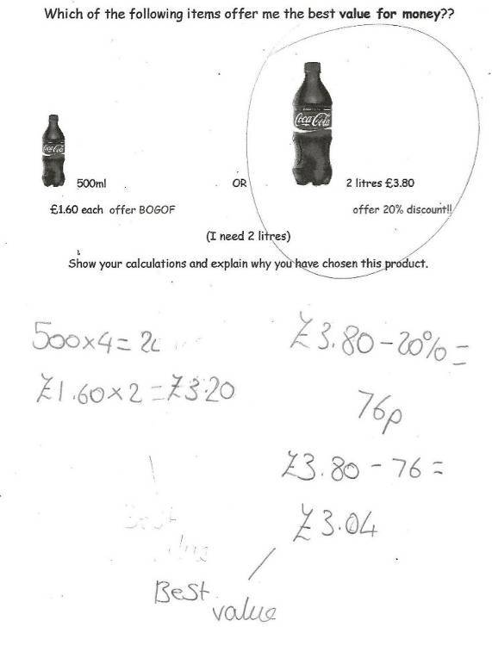
Figure 12: Work of Year 6 pupils on finding best value.

Figure 13: Year 5/6 pupils measuring sections of the school’s playground and preparing an estimate for the cost of re-tarmacing the surface.
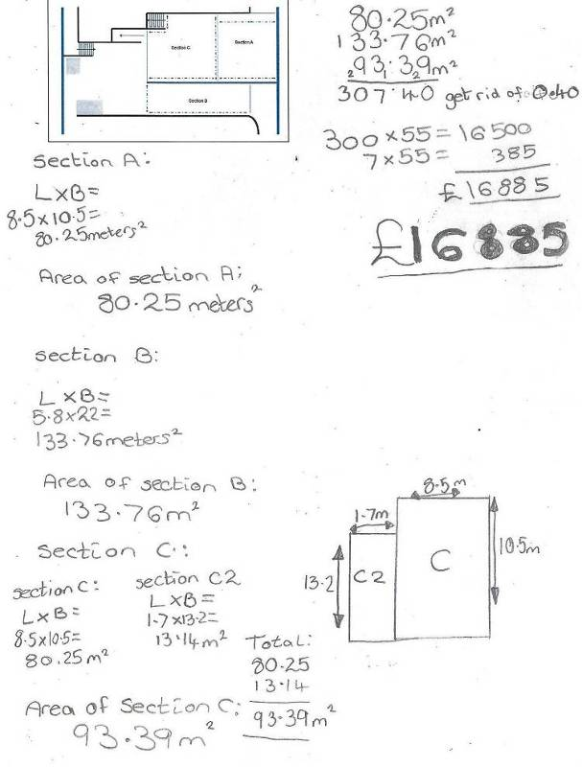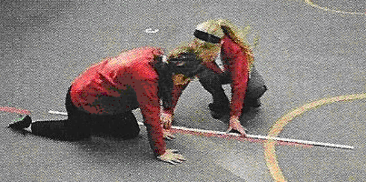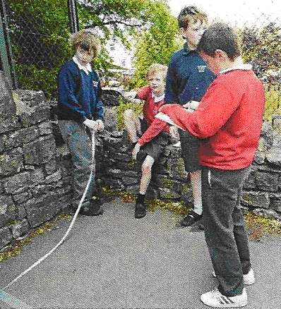
- Many relevant problems involved using money in real-life contexts. In one school, Year 5 pupils priced new equipment for the school’s playground from alternative suppliers who offered different discounts and they kept within the given budget. In another school, Year 5 pupils worked out the cost, including transport, of a school trip to different venues, and had to write a letter to parents explaining the total cost of the trip and arrangements for paying a deposit and the remaining cost by instalments. Year 3 pupils in another school were given a limited budget to buy items for a party.
- Younger pupils often work with smaller amounts of money. Year 2 pupils in one school worked in pairs to calculate the cost of buying six lemons at 5p each. They then went on to finding the cost of 12 and then 24 lemons. Some used only one strategy of counting repeatedly in fives, but most of the pupils (eventually in some cases) realised that doubling each answer gave the next answer. In figure 14 below, Pupil A explains that doubling the cost of six lemons, 30p, gives the cost of 12 lemons as 12 is double six. Pupil B counts in fives to obtain 60p and evaluates 12 x 5 by 10 x 5 + 2 x 5. The pupil goes on to calculate the cost of 24 lemons in three different ways.
Figure 14: Year 2 pupils’ approaches to calculating the cost of lemons.
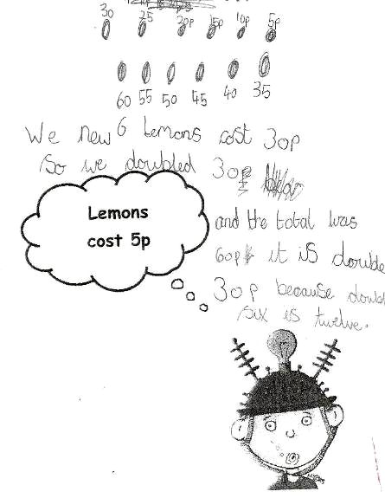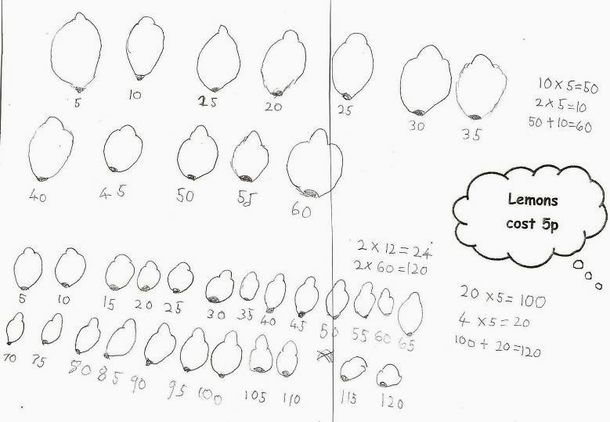 Pupil A Pupil B
- These Year 2 pupils attend a school which has used CAME (Cognitive Acceleration in Mathematics Education) materials in Key Stage 2 for several years and the allied ‘Let’s think’ materials in Key Stage 1. During the visit, pupils in all the classes observed tackled problems confidently and collaboratively.
- The example below, from the same school, illustrates some of the work of older pupils.
Year 6 pupils explored the relationship between the circumference and diameter of circles using a wide range of objects. The teacher allowed the pupils’ thinking to drive the lesson, so that their ideas were explored and refined. Initially the teacher and the pupils used string to measure around a large circle drawn on paper. They compared the lengths of the strings of the diameter and the circumference: ‘three and a bit’ says one pupil. Most pupils think that the relationship will be different for circles of different sizes; they are provided with a range of objects to find out for themselves, working in small groups.
By the end of the lesson, the pupils had revised their thinking about the relationship, deciding that the ‘bit’ was somewhere between a half and a quarter. The teacher introduced the symbol π (pi) with its approximate value of 3.14, and the formula C = π x D, which the class tested out on a circle of radius 6 cm, by measuring and calculation. When discussing what they had learnt that lesson, pupils spoke of the new vocabulary they had learnt, about learning from other people’s ideas, and how ‘things that were complicated earlier end up with a simple formula’.
- Cross-curricular use of mathematics included pupils’ research and comparison of data for Japan and Kenya, such as the proportions of people in each country who work on farms or in manufacturing, and those who can read and write. In an independent school, pupils’ geography field trip involved a considerable amount of mathematics including in devising and analysing an environmental survey and creating a profile of the river.
- Year 4 pupils in another school carried out a cross-curricular project into making and selling biscuits to raise money on Red Nose Day. The photograph below shows a display of their work, including work on nets when designing the boxes to hold the biscuits.
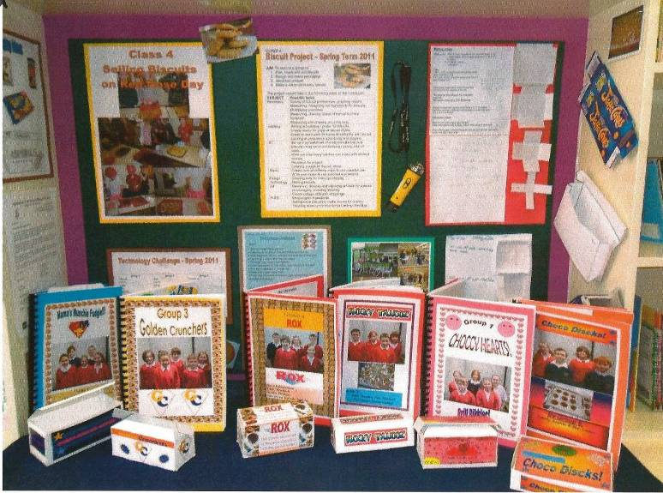

Pupils’ preferred approaches and their fluency in calculating
- Inspectors spoke with groups of pupils of different ages. The groups identified comprised younger pupils who were confident in adding and subtracting two-digit numbers, and older pupils who were confident in multiplying and dividing three-digit by two-digit numbers. In most cases, these were Year 3 and Year 6 pupils. Moreover, the groups did not generally include the most able pupils as inspectors wished to gain insight into the methods and thinking of those pupils who had not necessarily found acquisition of the methods easy. Inspectors encouraged pupils to use whichever method they preferred for each question that was discussed.
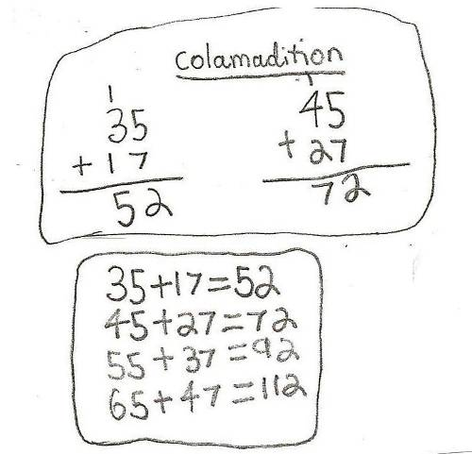
- Pupils who had been taught the formal algorithms used them quickly and accurately in the main. In a few schools, including a couple where the method for column addition and subtraction had not yet been met formally, the pupils chose to partition the two two-digit numbers: as discussed earlier, those who partitioned the second number only tended to manage subtraction more confidently and accurately. Almost all of these younger pupils recognised and could explain why the answer to 45 + 27 was 20 larger than 35 + 17, showing a good grasp of place value. Most could also use this idea to suggest similar sums that would generate answers 30 or 40 bigger than the initial question, as shown in figure 16 below.

Figure 15: A Year 2 pupil’s work showing her understanding of place value in generating a sequence of addition calculations.

- Older pupils were fluent and accurate with addition and subtraction. When presented with 121 x 8, almost all used the short multiplication algorithm. They used the same method again when multiplying 99 by 8 but, when asked if they could think of an alternative method, most could suggest 100 x 8 – 1 x 8. Not only is such an approach a useful mental strategy, but it shows implicit understanding of the distributive law, a(b – c) = ab – ac, with a = 8, b = 100 and c = 1 in this example. In a couple of schools where pupils have been taught few methods other than the formal algorithms, the pupils struggled to spot an alternative strategy, even when prompted.
- Pupils were also comfortable with long multiplication. One pupil excitedly showed the inspector his calculation of 9999999 x 9999999! When multiplying 248 by 25, most pupils chose to use the long multiplication algorithm to obtain 6200. One pupil spotted immediately that the product could be found by multiplying 248 by 100 and then dividing by four. Pupils quickly tuned in to inspectors’ questions that were seeking connections. They recognised that the product 24.8 x 25 was related to the previous question, 248 x 25. Most, but not all, were able to state what the answer was and why; they were clear that because 24.8 was ten times smaller than 248, then the answer would also be ten times smaller, 620. One group, however, suggested, incorrectly, that the answer was 62.00 on the grounds that ‘there are two numbers in front of the decimal point in the question and therefore two in the answer’. Discussion with the inspector about estimating the answer led the pupils to doubt their initial answer which they corrected to 620.0 but they were then unsure how to justify the new answer, given their mis-remembered ‘rule’ about counting decimal places.
- Most pupils used short division with confidence, for instance in calculating
432 ÷ 8 = 54. In one school which had mixed-age classes, the Year 5 pupils then repeated this method to calculate 431 ÷ 8 whereas the Year 6 pupils recognised the relationship and simply adjusted their earlier answer correctly. Pupils’ increasing flexibility with number as they progressed through the school was evident in almost all of the schools visited. These schools attribute such success to the importance they place on pupils using their number skills to solve a wide range of problems.
- When pupils were presented with 432 ÷ 16, most could spot the connection with 432 ÷ 8 with only initial hesitation over whether the answer would be doubled or halved, before justifying the correct answer of 54 ÷ 2 = 27. The reasoning that lies behind this pair of division calculations mirrors the algebraic reasoning required to answer this 2003 Trends in Mathematics and Science Study (TIMSS) question for 13–14-year-old pupils shown below (figure 16).
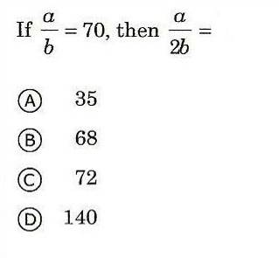

Figure 16: TIMSS question for
13–14-year old pupils.

- Only 38% of English pupils who participated in the 2003 TIMSS answered this question correctly (response A). This proportion was close to the international average of 40% but a long way below the 70% of Chinese pupils who answered it correctly. A key message of this report is that pupils whose understanding of number, its structures and relationships, is developed alongside their proficiency with arithmetic have the grounding so necessary for future learning, particularly of algebra.

What difficulties do pupils experience and how do schools overcome them?
- The schools’ awareness of difficulties that pupils might experience informs their policies and practices. Careful teaching aims to secure pupils’ understanding and skills. Although the schools vary in the particular ways they develop progression in pupils’ calculation skills, all emphasised the importance of careful sequencing and synthesising of interim, mental and formal methods. Speedy intervention when pupils falter ensures misconceptions are overcome. More than one school spoke of how a pupil is returned to the stage at which he/she is confident and learning is rebuilt from that point. Several schools made good use of skilled teaching assistants to intervene swiftly when pupils encounter difficulty. In one school, a pupil who was having difficulty with comparing amounts of money such as £4.62 and £2.65, and £2.33 and £2.37, writing answers using the symbols < and >, was taken by a teaching assistant to work one-to-one for a few minutes. This enabled him to return to the class and continue with the activities. In another school, pupils who experience difficulty receive short intensive support with a member of staff the following morning before going in to that day’s lessons. The small size of many classes in independent schools enables pupils to receive a lot of individual attention and overcome difficulties. Maintained schools tend to use a combination of in-class support and focused intervention strategies such as one-to-one support. The crucial aspect common to both groups of schools is rapid identification of pupils’ difficulties and timely well-focused help to overcome them. This was a feature of successful Finnish practice noted in the Ofsted report Finnish pupils’ success in mathematics.
- The difficulties that pupils experience can be separated into those that occur at some stage during the conceptual development of new ideas and those that relate to understanding how to record the method. Weak recall of number facts, such as number bonds to 10 and multiplication tables, and a lack of understanding of place value would impede all methods of calculation. The schools visited ensured that all pupils have a good grasp of number facts, structures and concepts. Many draw on a wide range of practical resources, particularly in developing fluency through a depth of experience in the Early Years Foundation Stage and Key Stage 1, and return to them when developing new ideas in Key Stage 2. The potential barrier of weak communication skills is overcome by a constant emphasis on developing pupils’ mathematical language and in one school where many pupils had significant communication difficulties, early specialist intervention for speaking and listening.
- Difficulties when using the formal algorithms often relate to pupils’ lack of understanding about how to record rather than how to calculate. A common obstacle with column addition and subtraction occurs where ‘exchange’ is involved; for example 45 + 27, or 45 – 27. Place-value cards and base 10 equipment (such as Cuisenaire rods and Dienes blocks) are often used to support addition and subtraction, particularly in Year 3, which one headteacher emphasised is such a critical year. Such use of practical equipment or visual images helps pupils to connect the recorded method with what is happening physically during the addition/subtraction, and was a key feature of most of the schools visited.
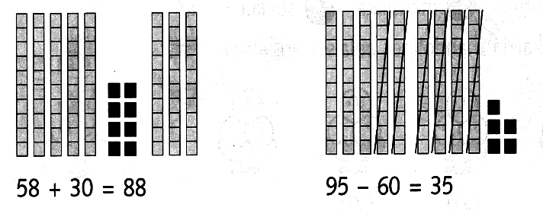
Figure 17: Base-10 image of two-digit addition and subtraction.

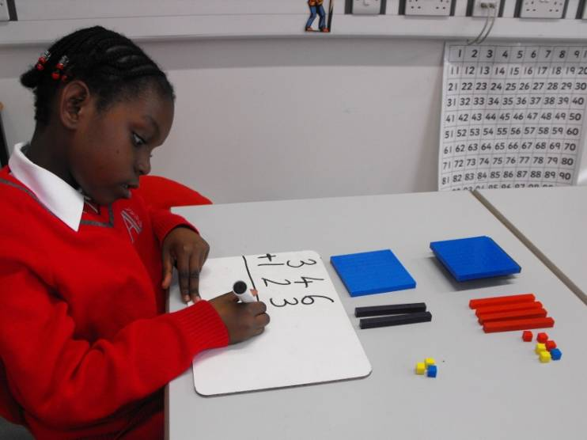

A Year 2 pupil using Dienes equipment to support
three-digit addition.

- Lack of fluency with multiplication tables is a significant impediment to fluency with multiplication and division. Many low-attaining secondary pupils struggle with instant recall of tables and often resort to finding specific products such as 6 x 4 by counting up in the required multiple (4, 8, 12, 16, 20, 24), sometimes even counting on their fingers from one term to the next. Most of the schools visited ensure that pupils know their tables and are confident and increasingly fluent in recalling associated facts; for instance 6 x 8 = 48 and 48 ÷ 6 = 8 and 48 ÷ 8 = 6. Practice with calculating single digit multiples of 10 and 100, for example 6 x 80 = 480, 60 x 80 = 4800, 6 x 800 = 4800, …, helps to ensure that the correct numbers are placed in the long multiplication grid, but errors still creep in with adding the entries in the grid. Pupils realise that careful setting out is important. When using the formal long multiplication algorithm, a common error nationally is that pupils sometimes ‘forget’ to write down place-holder 0s. In the schools visited, the teachers frequently emphasised place value, that multiplication by 48, for instance, is the sum of multiplying by 40 (four 10s, and hence the 0) and by 8 (units), rather than simply by 4 and by 8. Such attention to mathematical precision is an important element of these schools’ success.
- Few of the schools were completely satisfied with the methods they were teaching for long division. Several have reviewed their practice and have consequently reduced the number of interim methods. Having established short division, often called the ‘bus-stop’ method, some schools extend this method to two-digit divisors, supported by jottings. This requires careful setting out as two-digit remainders may have to be ‘carried’ during the calculation. One school commented that the lower and middle ability pupils are sometimes reluctant to use jottings, seeing them as a sign of weakness. It is not clear why pupils who are able to understand the short division method seem to become confused when trying to record the same steps in the formal algorithm but the issue is about recording, and not division itself. The independent schools who defer the formal method until Year 7 say that pupils manage it better then. Schools that teach the ‘chunking’ method for long division acknowledge that some pupils have difficulty spotting large multiples and that errors creep in with the repeated subtractions. Moreover, ‘chunking’ does not build on the method most schools are using for short division, and this discontinuity may contribute to pupils’ difficulties.

The role of technology and visual images
- While young children sometimes use calculators in role play in the nursery and reception classes and a few schools use them in Key Stage 1, most of the schools visited introduce calculators in upper Key Stage 2, principally for the purpose of checking by pupils of their answers to calculations. Often this is at a time when pupils are practising the written methods for long multiplication and division, fractions and percentages. One school emphasised the importance of pupils being able to estimate before using a calculator, saying that this helped pupils gain a sense of size in number through comparing their estimate with the calculated answer. However, the pupils interviewed in the sample of schools did not always use estimation confidently as a strategy when discussing answers to calculations with inspectors.
- The other principal use of calculators is as a tool when solving problems in mathematics or other areas of the curriculum, such as science, geography or design and technology. Where the focus is on developing problem-solving skills in a wide range of contexts, rather than simply practising calculation skills, using a calculator allows pupils to think clearly about the strategies they are using to solve the problem without getting bogged down in the mechanics of the actual calculation itself. In other words, space for thinking about problem solving is created. It also enables pupils to work with more complex but realistic numbers than they would meet using pen-and-paper methods. The pupils need to understand what is happening within the calculation in order to interpret the answer the calculator provides; for instance the meaning of a decimal answer in questions about whole numbers of people. In the schools visited, older pupils used calculators to solve a range of problems, interpreting their solutions appropriately in the context of the problem. Using calculators also enables pupils to ask and answer ‘what if?’ questions for themselves.
- Several of the schools acknowledged that they could make better use of calculators and information and communication technology in mathematics, an issue not restricted to this sample of schools. Pupils often have very limited experience of using computers to develop new mathematical ideas. Teachers commonly use interactive whiteboards to demonstrate new methods or present problems to solve. Examples of good practice observed during the survey include the use of the interactive whiteboard to show visual images to support calculations, for example in exchanging one block of 10 for 10 units in column subtraction. In another school, a teacher showed alternative methods side by side on the interactive whiteboard so that pupils could see how they related and debate the advantages and disadvantages of each method.
- One school has recently adopted the Singapore curriculum, which emphasises the consistent use of visual representation to aid conceptual understanding. For instance, ‘bar models’ are used to represent the relative sizes of quantities and fractional parts. The images below show use of bar models in solving addition and subtraction problems in Year 2.

Figure 18: Pupils’ use of visual representation in solving problems.
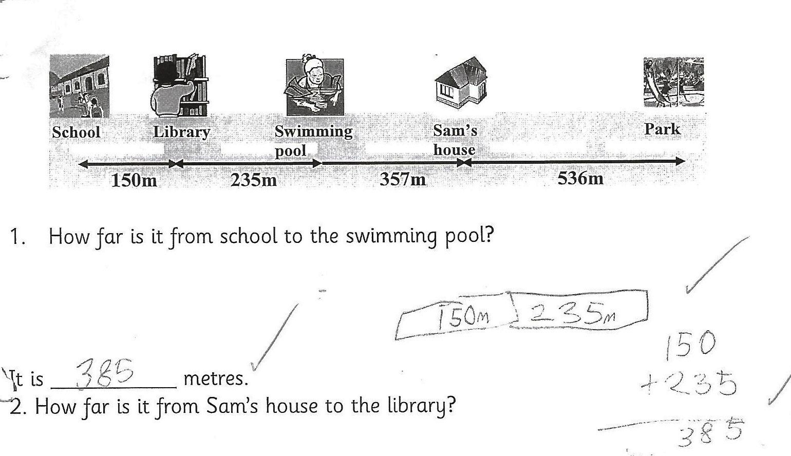
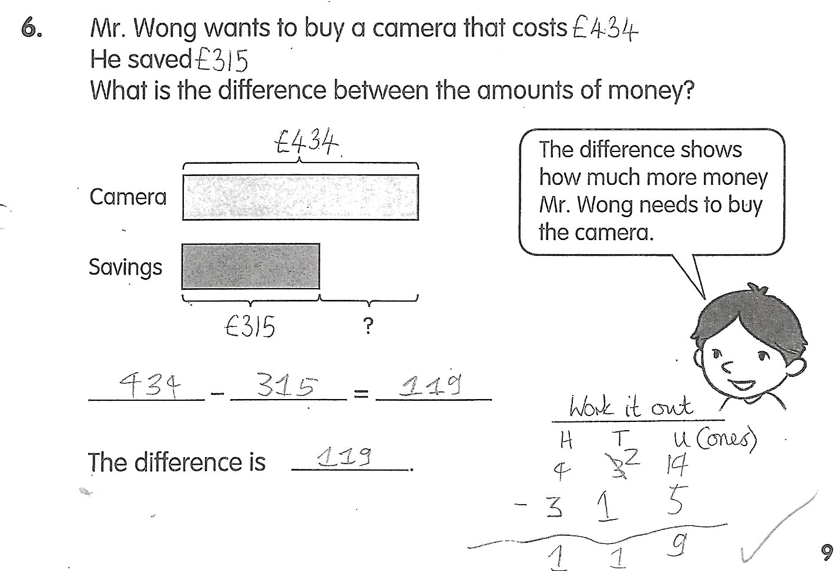

- The Singapore textbooks and teachers’ guides draw on multiple images when developing calculation skills, including illustration of base-10 apparatus as well as partitioning numbers, as shown in the extract from a teachers’ guide in figure 19 below.

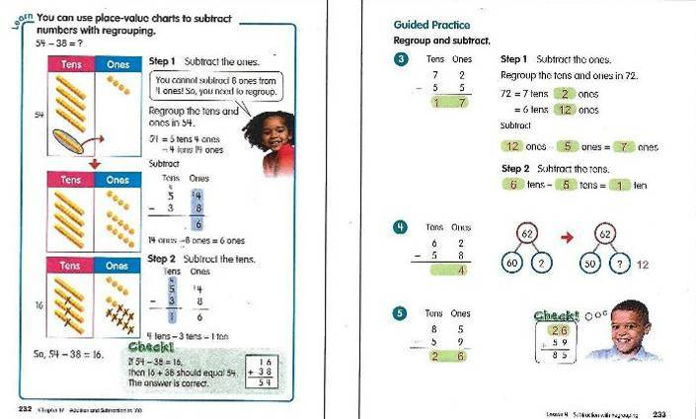
Figure 19: The left hand illustration shows one 10 being exchanged for 10 ones in the subtraction of 38 from 54, with addition being used as a check. The right hand illustration models column subtraction with partitioning of 62 into 50 + 12 as a prompt in the second question.

Calculation policies
- One of the differences between the maintained and independent schools visited was that while all of the maintained schools had calculation policies, most of the independent schools did not (although some had policies that set out the aims and approaches to their work in mathematics more generally). Of greater importance than having a policy, though, is the way the staff in the schools work together to adapt the policy or guidance on teaching approaches for the pupils in the school. This work is often led by a teacher who has specialist knowledge, sometimes the headteacher. A crucial element is the involvement of all staff in professional development on aspects of the policy, for instance in developing progression in subtraction from the early years to Year 6. This means all the teachers and teaching assistants see how the methods in any year build on what went before and feed into what is learned later. Moreover, the policies reflect particular adaptations such as a reduction in emphasis on or removal of some interim methods, for instance ‘chunking’ as a method for long division, although one school has strengthened its use for all work on division. It was clear from discussions with staff and scrutiny of pupils’ work that the policies are implemented consistently. In essence, the policies capture effective whole-school approaches to developing securely pupils’ calculation skills, mental and written. Moreover, the schools evaluated and reviewed their policies on a regular basis.
- The independent schools visited generally use textbook schemes, often supplemented by other materials, as a structure for progression in calculation skills but decisions about where the emphases lie and the approaches to adopt are usually left to individual teachers’ professional judgement. Most of the schemes and associated teachers’ guides incorporate many of the methods included in the Primary National Strategy framework and thus there is more in common with the maintained sector than might appear on the surface, particularly in Key Stage 1 and the Early Years Foundation Stage.

Subject expertise and continuing professional development
- A high level of mathematical expertise was evident in most of the schools visited. In several of the independent schools, pupils are taught by specialist mathematics teachers from around Year 4, and class teachers before that. This aligns with the change from pre-preparatory and preparatory departments or schools at age eight. On average, therefore, pupils in upper Key Stage 2 in independent schools receive more specialist mathematics teaching than pupils in maintained schools. Innovative practice in one independent school couples Year 5/6 pupils’ effective learning of National Curriculum mathematics (including problem solving), taught by the class teachers, with other regular lessons on a diverse range of mathematical topics, such as the design of a roller coaster ride or the Königsberg bridge problem, taught by the school’s secondary mathematics specialists. As one pupil put it, ‘we do weird and wonderful things in those lessons’.
- In a few of the schools, subject or senior leaders are well qualified in, and/or actively involved in, mathematics education research. One independent school regularly works with researchers from the neighbouring university: staff show a keen awareness of pedagogy and are particularly reflective about their practice. A recently appointed subject leader at a maintained school has conducted action research on pupils’ calculation skills and is using the information to refine policies and guidance for staff.
- Some of the maintained schools have particularly strong track records of developing the mathematical expertise of their staff. The ways they do this include use of the former five-day local authority courses for all new staff; the appointment of a mathematics graduate as subject leader; subject leaders’ participation in the Mathematics Specialist Teacher programme, which includes a responsibility to work with colleagues to develop their subject knowledge and pedagogy; and training for teaching assistants leading to qualifications such as GCSE mathematics and Early Years degrees. A key feature of the best practice is that schools make sure that all staff (teachers and teaching assistants) work together on mathematics to develop their expertise and understanding of progression in aspects of mathematics. Several schools supplement such collaborative approaches to professional development with joint lesson-planning time between teams of teachers or teachers and teaching assistants. All of this underpins the professional understanding that supports effective planning for progression day by day and over time. Because staff are well informed, they are aware of the early signs of pupils’ difficulties and misconceptions and act quickly to tackle them, adapting the lesson accordingly. Lesson planning is regularly annotated and subsequent planning ensures any residual issues are taken into account.

Working with parents/carers
- An area developed by many of the schools, independent and maintained, is information for parents about how their children learn mathematics. This often takes the form of evening workshops (‘learn with your child’, ‘keep up with the kids’), but also includes drop-in sessions. Information from one high quality and well-attended parents’ evening showed parents tackling mathematics questions such as: 25 x 19, 5% of 86, 248 – 99, 103 – 98, 1+2+3+4+5+6+7+8+9+10+11.
- These well-designed calculations led into discussion about methods that are taught and the mistakes and misconceptions pupils can make and have. The slides below summarise the school’s aims to develop pupils’ confidence, proficiency, problem-solving skills and conceptual understanding. The workshop presentation moves on to discussing specific ways that parents can help their child, including by playing a range of family games, discussion about the numbers all around us, and opportunities for calculating.
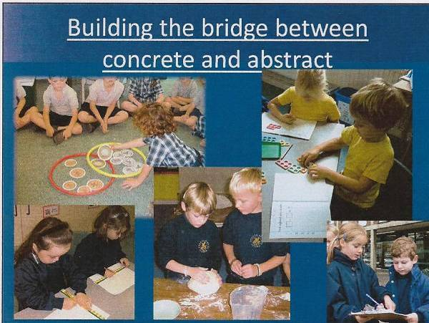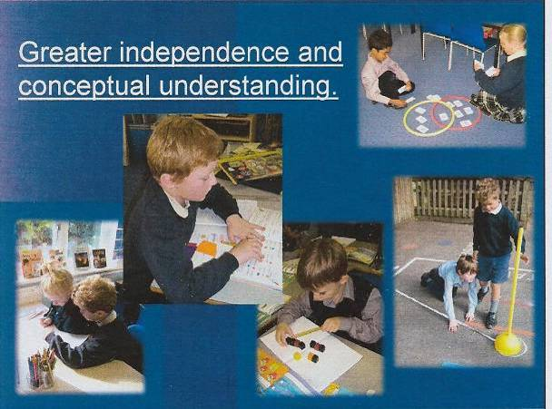
- Some of the schools visited provide parents with guidance based on their calculation policies, and one provides materials for parents tailored to their child’s specific difficulty. The importance of mathematics is also promoted through newsletters.

Notes
Inspectors visited a sample of 10 maintained and 10 independent schools, all of which have strong track records of high achievement in mathematics. Other equally successful schools which were not selected for the survey may well be able to recognise aspects of their own best practice within this report or, indeed, have some striking differences from the schools in the survey. Nevertheless, the survey found key common factors in the ways the schools tailor their work in mathematics to meet their pupils’ needs and realise their potential. It is the cumulative effect of each school’s work and the expertise of its staff that makes the difference to pupils’ fluency in calculating, solving problems and reasoning about number.
Inspectors visited each school for one day during May and June 2011. Initial evidence was collected through pre-visit telephone discussions with senior staff and/or subject leaders about: the age at which pupils meet vertical addition and subtraction and methods for long multiplication and long division; the school’s view of the reasons behind their pupils’ success in these methods; the difficulties pupils experience and how the school overcomes them; and in what ways pupils use their arithmetic skills.
During the visits, inspectors gathered evidence through:
- observations of lessons and scrutiny of pupils’ work
- discussions with senior and subject leaders and with teachers whose lessons were observed
- discussions with groups of pupils during which pupils tackled some calculations and problems, and talked about their methods and thinking. Most of the pupils were middle- to lower-attaining, but known to be relatively competent with the arithmetical methods appropriate for their age. These pupils, rather than their higher-attaining peers, were chosen in order to gain insights into how the schools enable such pupils to succeed and thus provide a potentially important key to how standards nationally might be raised further.
- analysis of documentation such as calculation policies, schemes of work, resources and guidance for staff, information about intervention strategies and professional development in mathematics.

Further information

Publications by Ofsted
Mathematics: understanding the score, (070063), Ofsted, 2008; www.ofsted.gov.uk/resources/070063.
Finnish Pupils success in mathematics, (100105), Ofsted, 2010; www.ofsted.gov.uk/resources/100105.

The Primary National Strategy
Following the end of the National Strategies’ contract on 31 March 2011,a number of key and popular teaching and learning resources were updated and adapted to enable users to access the content archived by the National Archives. Note that the interactive functionality and features previously available on the National Strategies website is not be available on the archived versions. The link below is to the primary mathematics section of the archived materials. http://webarchive.nationalarchives.gov.uk/20110809091832/http://www.teachingandlearningresources.org.uk/primary/mathematics.

The Mathematics Specialist Teacher programme
Information about this programme is available the National Centre for Excellence in the Teaching of Mathematics (NCETM) (and on the websites of individual university providers). www.ncetm.org.uk/news/33949.
The programme stemmed from a recommendation in the Independent review of mathematics teaching in early years settings and primary schools, DCSF, 2008.
http://publications.education.gov.uk/default.aspx?PageFunction=productdetails&PageMode=publications&ProductId=DCSF-00433-2008.

Trends in international mathematics and science study (TIMSS)
TIMSS is an international research project that provides data every four years about trends in the achievement of pupils aged 9–10 and 13–14 in mathematics and science over time. Approximately 150 primary and 150 secondary schools from each of 60+ countries were selected to participate in the 2011 assessments. www.nces.ed.gov/timss

Cognitive Acceleration in Mathematics Education (CAME)
CAME draws on the research of Jean Piaget and Lev Vygotsky and focuses on questioning, collaborative work, problem solving, independent learning and challenge. It uses a selection of challenging classroom tasks which emphasise 'big ideas' or conceptual strands in mathematics.
www.cognitiveacceleration.co.uk

Annex A: Schools visited
Independent schools | Location
Dragon School | Oxford
Froebel House Preparatory School | Hull
Ranby House School | Retford
St Joseph’s School | Launceston
St Olave’s School and Clifton Pre-Preparatory School | York
Terra Nova School | Holmes Chapel
The Cedars School | Reading
The Manchester Grammar School (Junior Dept) | Manchester
Town Close House Preparatory School | Norwich
Winterfold House School | Kidderminster

Maintained schools | Location
Ark Academy | Wembley
Coxhoe Primary School | Durham
Grafton Primary School | London N7
Heversham St Peter's CofE Primary School | Milnthorpe
Lanesfield Primary School | Wolverhampton
Lyminge Church of England Primary School | Folkestone
Mead Vale Community Primary School | Weston-Super-Mare
St Bernadette's Catholic Primary School | Stockport
St Margaret Ward Catholic Primary School | Sale
St Thomas More Roman Catholic Primary School | Chatham

Michael Gove, MP, speaking at the Advisory Committee on Mathematics Education Annual Conference 2010, ‘Mathematical Needs - Implications for 5–19 Mathematics Education’ 2 March 2010.
The importance of teaching: the Schools White Paper, DfE, (2010); www.education.gov.uk/childrenandyoungpeople/strategy/laupdates/a0070929/the-importance-of-teaching-schools-white-paper.
Place value is determined by the position of a digit within a number, for instance in 6135, the value of the 3 is three tens, and the 6 is six thousands. Number bonds include useful pairs of numbers, such as 1 and 9 or 3 and 7, both pairs of which add up to 10.
The Trends in International Mathematics and Science Study is an international assessment of the mathematics and science knowledge of pupils aged 9-10 and 13-14 years around the world.
Finnish Pupils Success in Mathematics (100105), Ofsted, 2010; www.ofsted.gov.uk/resources/100105.
The combination of subject knowledge and understanding of the ways in which pupils learn mathematics is described as ‘subject expertise’ in the report Mathematics: understanding the score, (070063), Ofsted, 2008; www.ofsted.gov.uk/resources/results/070063.
The Mathematics Specialist programme is a national two-year Masters-level course through which participating teachers extend their knowledge, skills and understanding of mathematics and related pedagogy, and develop the skills to support other colleagues in mathematics.

