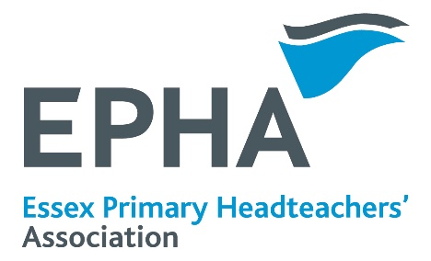
EPHA CONFERENCE NEWS

DEPUTY HEADS’ CONFERENCE
Friday 9th October 2026 Colchester Football Stadium
Further information and booking forms will be sent to all schools in late June.

SMALL SCHOOL HEADS’ CONFERENCE
Wednesday 14th October 2026 –The Lion Inn, Boreham

SAVE THE DATE
Next year’s EPHA ANNUAL HEADTEACHERS’ CONFERENCE will be held on Friday 19th March 2027 at Chelmsford City Race Course.
More information in December 2026.
You can contact EPHA through the website
www.essexprimaryheads.co.uk
via Pam Langmead, Professional Officer, at pam@langmead.me.uk
Harriet Phelps-Knights EPHA Chair,
via Janet Duke Primary
Termly meeting with Local Authority officers

The EPHA Executive met with LA Officers on 7th May 2026. The agenda included:
- An update from Clare Kershaw about national and local reforms
- Ofsted key themes from Essex inspections under the renewed framework
- A safeguarding update from Jo Barclay
At the EPHA Executive meeting earlier in the day, headteachers discussed:
- Feedback from various meetings and committees, including Schools Forum
- A discussion about supporting headteachers, before and during Ofsted inspections, and more generally
- Input from the Essex Research School
The minutes of the Executive meetings are available on the EPHA website
http://essexprimaryheads.co.uk/meetings

EPHA Meetings Summer term 2026

N-EAST Wednesday 17 June Colchester Community Stadium
SOUTH Thursday 18 June Greenwoods Hotel, Stock
WEST Wednesday 24 June Manor of Groves
MID Thursday 25 June The Lion Inn, Boreham
Meetings start at 9.00 am. The agendas will be emailed to schools at least a week in advance of the meeting, and are available on the EPHA website.
See overleaf for the meeting dates for the 2026/27 school year.
The EPHA ANNUAL GENERAL MEETING will be held on Thursday 1st October 2026 at the Lion Inn, Boreham, starting at 9.00 am. More information in the autumn term.
EPHA funding for 2026/27
A reminder that the funding contribution for EPHA will continue to be top-sliced from the Schools Block, so no invoices will be sent to schools.
Termly meetings will continue to be “free” to all primary headteachers, along with the website, cluster briefings, training events, and advice and support from the Professional Officer and EPHA Executive. See our paper on “what headteachers get for their contribution to EPHA” to see what great value we offer!
Thank you for enabling EPHA to continue to offer this support to primary headteachers.

Review of the school year from the NE EPHA Chair
Where does the year go? I can’t quite believe we are nearing the end of the summer term again! It seems that much of the school year is a massive slog with all sorts of issues, disasters and often incredulous things going on, and you can’t wait for it to end. Then you blink and you’re in the maelstrom of the last part of the summer term, racing through assessments, report writing and reading, sorting staff for the following year and trying your best to keep up!
I remember being told many years ago that; ‘If you stand still long enough in education, you become an innovator.’ I couldn’t really grasp the concept of this nearly 30 years ago when I was told this, but the saying holds true! We seem to be revisiting the same issues again and again. SEND has vexed us all this year, funding and the lack of it, has again occupied our brains, as it always has for decades. Yet we all still turn up each day to do the best we can for the children and the communities we serve.
Ofsted has started its new inspection framework this year, with some mixed results. We hope that over the coming years there will be a little more flex in the system and some slightly less difficult judgements. We need to make sure we support each other through this and the other things that challenge us day in and day out.
EPHA has again been working hard with colleagues at a local and national level to get the best it can for Headteachers. This year our priorities have been to engage in Local Government Reorganisation, focus on Early Years and support for Ofsted, and a continuous focus on SEND, with a final, but very important, priority of Headteacher well-being.
Local Government Reform is going to occupy the minds of both the local authority and EPHA in the next 2years. Navigating five Unitary Authorities is going to be very challenging. How this will look for us as school leaders is not quite yet known. The biggest risk is the breaking up of EPHA. We don’t realise how lucky we are to be able to meet like this on a termly basis and have a group of heads across the county working towards the same goal. We have to find a way to stick together. Please let us know your views. about the future of the Association.

NEWSLETTER
Summer Term 2026

