‘Was that brilliant or what?’ Engaging Reception children in phonics: Lambton Primary School
URN: 108817
Local authority: Sunderland
Date published: 21 September 2011

Brief description
The content of Letters and Sounds is linked to current themes in phonics sessions. ‘Gear the Fish’ engages children in segmenting and blending consonant digraphs and vowel graphemes and sparks a hunt for Jimmy the class toy.

Overview – the provider’s message
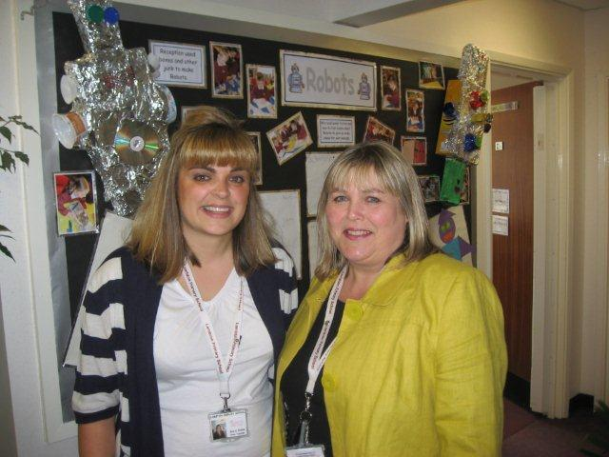
‘The curriculum in the unit is never the same two years running – we’re constantly refining it and looking to things we can add that will meet the needs of our children. It’s the flexibility and the links that make it so successful and so right for the children. I want them to be actively learning, doing what children should do and getting a broad range of experiences. I make sure that there are high-quality resources to support the experiences. Kate is an exceptional Early Years practitioner. She’s got such a good relationship with the children and she knows just how to get the best out of them. The Reception children have really moved on. They’ve been challenged and, often from a low starting point, all have completed Phase 3 and some are working well into Phase 4. Their reading is stronger than their writing, but a good proportion are writing confidently in sentences.’
Kate Erskine and Susan Bell
Susan Bell, headteacher

The good practice in detail
‘I follow the content and structure of Letters and Sounds phases most of the time but I will jump here and there if the content fits with our theme’, says Kate Erskine, the Reception class teacher. ‘I’ve tried things many different ways and used ideas from courses. What works best is when you use a character, an action or a context - something to help the children remember the sound and the letters. If you do things exactly the same thing every day, it is boring. The only same thing I do is the recap of sounds - the revisit and review - but I often let the children choose how we do that. They really like the “Beat the clock” game. Learning has to be fun so I try to keep it hands-on and active. If the children enjoy what they do then they gain in confidence and are more likely to remember and use their learning. When the theme was robots, we talked about oil so that was a chance to rehearse oi. The children loved writing oi and oi words in cooking oil, then we added soil and put it on cooking foil! In the Early Years Foundation Stage unit, we plan as a team and share ideas of how to make things more interesting, how to enhance something that is going well and how to pick up on what the children have talked about. Then the Nursery teacher and I plan our own phonics sessions. We take photographs of what the children do as evidence of their learning and many examples go into the children’s own “My Learning Journey”. I then add the link with the curriculum and profile point.’
An example of a session
0900 – 1030: Reception class session of phonics followed by adult-led group session and child initiated activities.
Current focus: sea life (impending visit to ‘Sea Life’ and the beach)
Recent themes: Rainbow fish and pirates

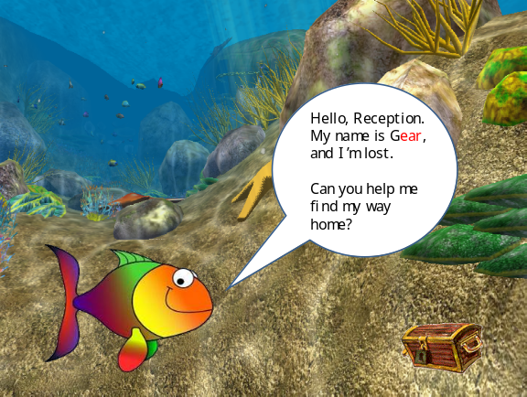
Knowing that some children were not 100% sure of some of the trickier vowel graphemes in Phase 3, Letters and Sounds, such as ur, er and ear, Kate looked at ways in which she could revisit them in a purposeful way. She decided to create a character named ‘Gear the Fish’ (based on the Rainbow Fish which the children had loved) who would ask the children for help in making his way home by sorting out real ear words from false ones. With a teaching assistant, Kate compiled a presentation for the interactive whiteboard which ended with a message from a pirate (who had visited the class previously) to say that he had hidden Jimmy the class giraffe (a much loved soft toy that goes home with a child each week) but had left some instructions on how to find him.
Gear the Fish
Kate knew exactly what she wanted the children to achieve during the morning. Her detailed preparation and organisation of resources indoors and outside ensured that the links between activities were seamless. She began by telling the children that they were going to practise sounds they knew and one they were less familiar with, and then quickly moved to using flash cards to evaluate their recognition of letters, consonant blends and vowel graphemes. There was praise for a child who remembered a particular blend and repetition of all the blends that were over-sounded. The children’s concentration deepened when Gear appeared on screen and the children were quick to segment and blend his name.
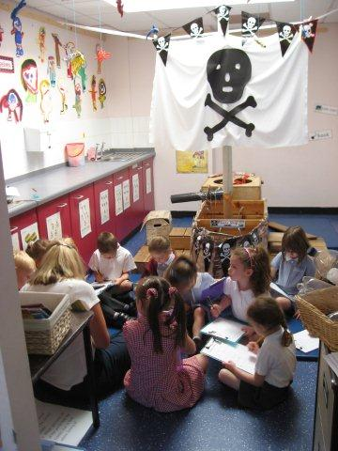
The children were keen to help Gear by either whispering ear if the ear word on screen was real or loudly if it was not. They were delighted to see Gear move across the screen when they identified near rather than thear as the real ear word. Each new pair of words led to segmenting and blending and in some cases, as with fear, some discussion about the meaning. There was much laughter when Gear said he was ready for a meal of fish fingers. As he swam off, the children noticed the bottom of a ship at the top of the screen which prompted the view that it could be a pirates’ ship. When a message was thrown down from the ship, there was palpable excitement. The children helped Kate to read the text which incorporated all of the real ear words that had been used in the Gear pairs and there was much laughter when the children read that Jimmy would be wearing a beard (the one unused ear word from the recommended list in Letters and Sounds: principles and practice of high-quality phonics). Kate then asked two groups if they were willing to help her to find Jimmy, suggested that another group might want to go with the teaching assistant to hunt for treasure in the outdoor pirate ship, and the rest to decide what they wished to do, reminding them of the links between activities and her expectations.
The pirate ship in the role-play area
In the role-play area, in front of the pirate ship, the teacher and 11 children found the clipboards left for them by the pirate and the children listened carefully as Kate read the first instruction.
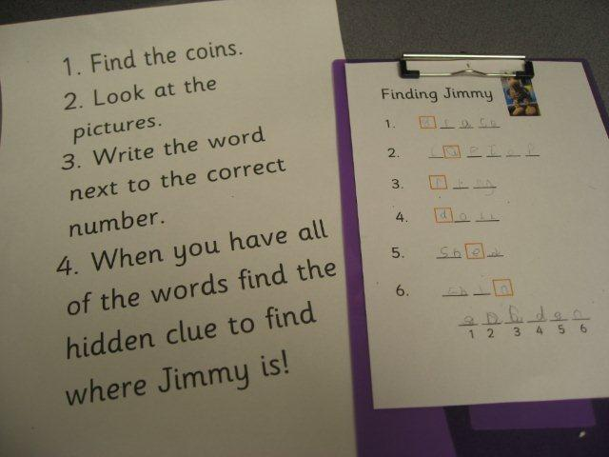
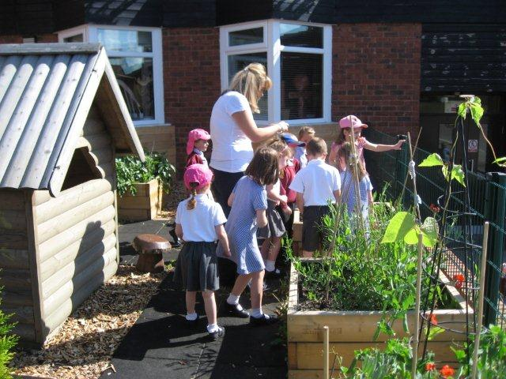
The children were quick to hunt for the coins (from the treasure chest they had previously made), then to place them in numerical order and to identify the picture on the backs. With Kate’s prompting about instruction three, they began to fill in the missing letters on their sheets: each word used known graphemes, for example, doll, grass, ring. Kate observed the group carefully. She encouraged and modelled segmentation for spelling and reinforced correct letter formation. Some children were slightly nonplussed by instruction four but helped one another.
The clues to help find Jimmy!
Children search for Jimmy in the garden

When they found that the hidden clue revealed garden the children were raring to go and rescue Jimmy. He was found in a box under the soil in one of the raised beds. There was much delight when his eye patch and beard were revealed and one girl promptly opted to comfort him after his ordeal.
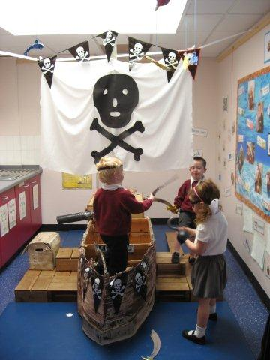
Several boys and girls chose to return to the pirate ship and became totally engrossed in highly imaginative scenes that involved lifting and lowering the anchor, hiding the treasure chest, taking charge of the ship’s wheel, sailing off and getting individuals to walk the plank. They donned eye patches, play fought with cutlasses and hand hooks, and used familiar vocabulary and phrases that had formed part of previous work. Nursery children were content to sail toy ships around the island, to talk about and to draw their adventure.
Imaginative play
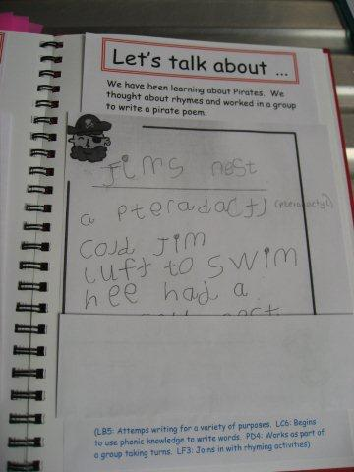
Activities such as these led to writing, including poems about pirates and messages to put in bottles, and Kate had used these writing occasions as assessment opportunities. A copy of the writing was placed in each child’s ‘My Learning Journey’ with an explanation for parents and carers about what prompted the writing and how it linked with scale points in the Early Years Foundation Stage Profile. For example, ‘CLL linking sounds and letters, scale point 6: attempts writing for a variety of purposes.’
A pirate poem
Other ‘pirate’, ‘sea’ and ‘Gear’ language activities were happening elsewhere. Two boys and a girl spent at least 30 minutes talking to each other about their drawings and their writing ‘under the sea’ – created from fixing paper to the underside of a table with felt tip pens and pencils above on the ‘sea’ cloth along with shells, driftwood and photographs of sea creatures.
Outdoors, others were looking closely at fresh fish to see if, like Gear had said, fish did have ears. A teaching assistant encouraged them to talk about and to spell the different parts that they could see: ‘tail’, ‘fins’, ‘gills’ and ‘teeth’.
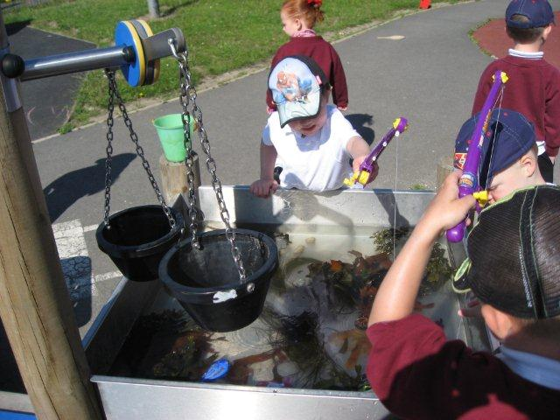
At the same time, Nursery and Reception children fished side by side in a ‘pool’ complete with seaweed and model rock pool creatures. One boy confidently and repeatedly showed the others how to cast and to reel in while telling them how the fish ‘could be a salmon or a mackerel’.
Children fishing in a ‘pool’

Other children were exploring the world under the sea beneath the climbing frame. The hanging cloths created an area of shade and mystery. Several children stayed for a very long time creating their own sea world. Many showed determination and perseverance in putting on flippers, masks, snorkels and goggles before ‘swimming’ and ‘diving’ as they moved around and on the frame. Susan Bell, headteacher, commented that it was at times like this that the value of giving children good quality, genuine items becomes highly apparent in the quality and intensity of the play. Reception and Nursery boys and girls helped and encouraged one another, and several extended their play into other areas before returning to dive and swim again. As 90 minutes of intensive, high-quality play and learning came to an end, Kate Erskine told the children it was time to gather together as a group. One boy’s comment said it all; ‘Was that brilliant or what!’.

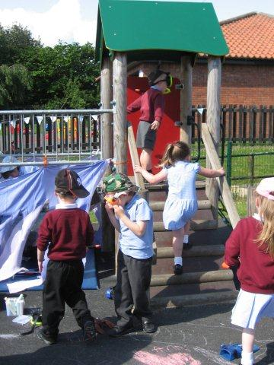
Provider background
Exploring beneath the sea
Lambton Primary School (www.lambtonprimary.co.uk) is in an area of private and housing association homes at the heart of Lambton Village in Washington, Tyne and Wear. The school’s logo includes the Lambton Worm, part of the folklore of the area. The school was built in 1979 to serve what was then a new town and the school has children whose parents were some of the school’s first pupils. Employment rates have fallen over the last two years and there has been a rise in the proportion of children eligible for free school meals. The school offers flexible nursery attendance arrangements, out of school childcare and daily toddler groups, drop-in sessions for childminders and activities linked to children’s centres. The school was judged to be outstanding when inspected in September 2008 and holds several national awards. There are currently 212 pupils on roll with 49 part-time Nursery children and 30 in the Reception year. The Early Years Foundation Unit has its own access area, garden and outdoor space with different surfaces and play equipment.
To view other good practice examples, go to: www.goodpractice.ofsted.gov.uk/

