Three of 24 ways for children to succeed in the Early Years Foundation Stage: Throston Primary School
URN: 111612
Local authority: Hartlepool
Date published: 31 August 2011

Brief description
This school regularly adapts planning and provision to reflect the changing interests and needs of the Nursery and Reception year children in the Early Years Foundation Stage (EYFS). The staff identify 24 facets of how their approach fosters and builds on progress, especially for boys.

Overview – the provider’s message
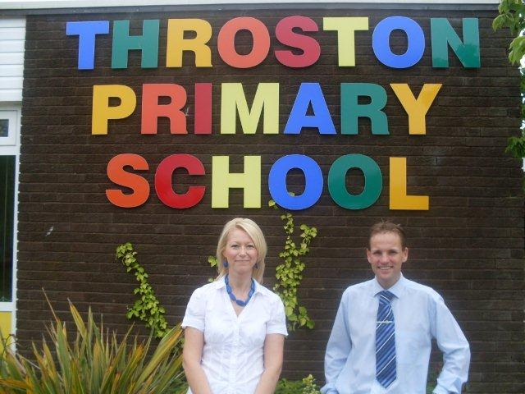
“If we get it right in the Early Years Foundation Stage, the whole school reaps the benefit. We want every child to make the best progress, especially in reading and writing. We want the highest quality for the children and they give us high-quality learning in return. We invest highly in the Foundation Stage ‘Village’ (the school’s name for its Nursery and Reception classes) and the governing body rightly wants to be sure that it is paying off. It’s a question of getting the balance right, whether it’s between adult-led and child-initiated activities, indoors and out, early or late in the school year or between Village and school priorities. For example, if we get the transition from the Village to Year 1 right, we can hope for continuous progress. That is why we have decided this year that one of our Reception teachers will move with the children and teach in Year 1 from September. We have taken the model of continuity further in that a nursery teacher will also teach in Reception from September. Throughout the year and especially this time next year, we will see how well these changes have worked. Our children do well and we want to sustain that and also to increase the proportion who move into Year 1 having met scale points 8 and 9, especially in personal, social and emotional development. If boys and girls are highly self-motivated, listen well to each other and reflect on their own learning, they are well set for the years ahead.”
Mark Atkinson, headteacher and Sonya Black, deputy headteacher

The good practice in detail
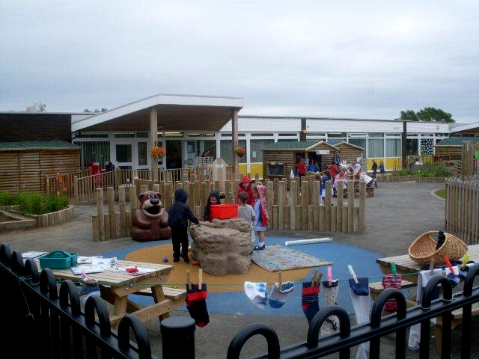
‘We have identified 24 facets of what we do; all 24 are continually in use to some degree or other so there is no priority listing but sitting near the top are rigorous self-evaluation, following children’s interests and altering the environment’, says Mark. ‘We initially plan the curriculum on a theme but you never know how it will pan out. Things happen and children’s interests often go in a completely unforeseen direction. We follow that direction and try to personalise the curriculum and adapt to the children’s needs to make progress and build on progress. We have done a lot specifically to heighten boys’ engagement in activities that catch their interest and we can see the results in their reading and writing.’
- Rigorous self-evaluation

‘We are constantly trying to get the balance right’, said Sonya Black. ‘We have our development plans linked to our priorities and we keep track of how well we are doing. We talk to the children about what they have done, we discuss it as a team and decide what we need to do to adapt or change what we and they are doing.’
A good example is the recent adaptation of the central snack zone to also form an area for specific independent learning activities – the Learning Zone - to provide a bridge between adult-directed and child-chosen activities. The staff had noted that although the Reception children were ‘ready’ for independent learning, they did not always follow up activities and suggestions shared in adult-directed sessions, particularly the boys. So it was decided to look for a middle way to encourage children to work independently on activities that have been introduced in adult-led sessions and which would ensure that the children rehearse, use and apply their skills in literacy and numeracy.
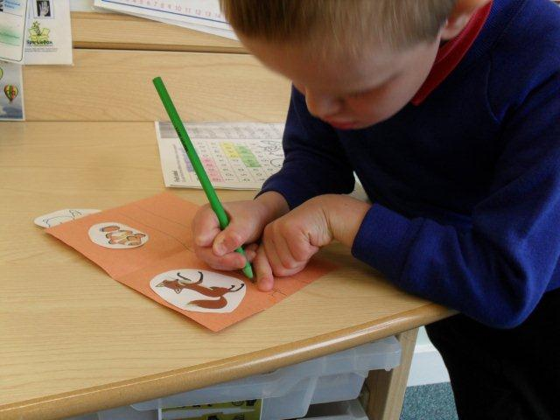
Different groups of Reception children are allocated a specific day when they must at some time visit the Learning Zone and select activities from the range available. No adult is based in the zone although adults spend time in the area talking to the children and observing them. A colour-coding system ensures that the children choose from activities at the right level of challenge for them. The children tell the staff that they find it exciting. Unprompted visits to the Learning Zone have increased and children are staying a considerable time, concentrating hard, engaging with others and talking about what they are doing. They are also keen to show what they have done.
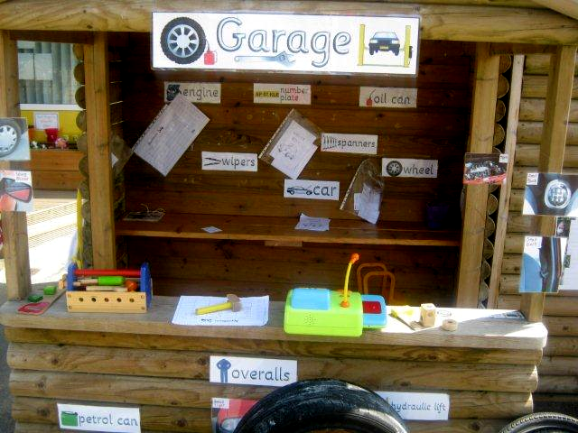
Tasks linked to the current theme of Travel and Transport have proved especially appealing to the boys who have been absorbed in drawing toy cars, describing and listing the differences between them as well as exploring and recording different ways in which the cars can be parked. Staff observe how children help one another using their knowledge of letters and sounds in reading and writing labels, lists and simple sentences. The most direct gains are in those aspects that secure the evidence of attainment at scale points 7, 8 and 9, especially in dispositions and attitudes, social and emotional development, language for communication and thinking, and writing.
- Following children’s interests

Over a year, the staff provisionally plan experiences and learning based around a theme and topics. When a theme is suggested, and before planning begins in earnest, staff ask parents and carers to talk about the theme to their children, to note what the children already know and what they would like to know. Their comments are then used as the basis for planning. The growing excitement for many boys in the film Cars 2 led staff to set up several related activities, including the outdoor garage. For one reluctant writer, this led to a significant step forward in attempts to write the names of car-parts in his role as mechanic.
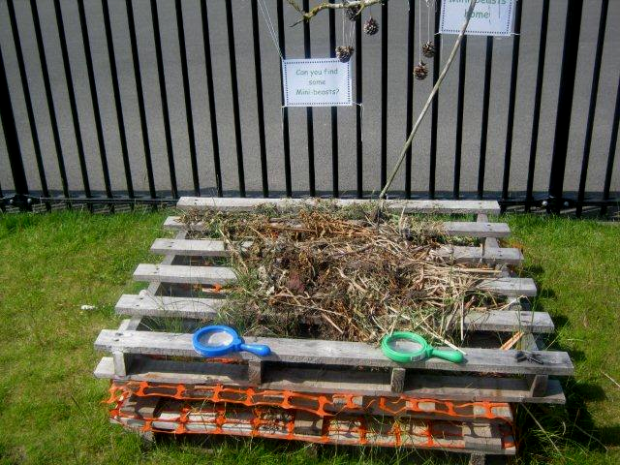
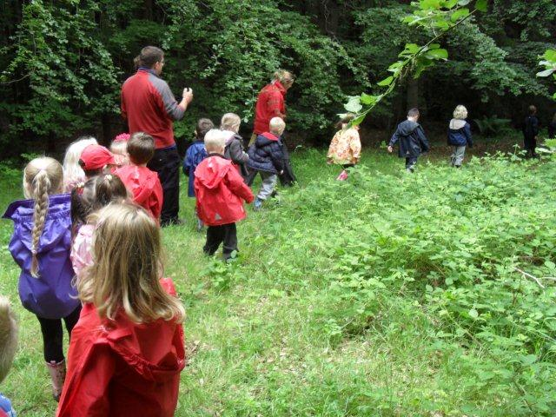
‘It’s finding that missing link that makes the difference,’ says Sonya, ‘and often one little thing leads to another’. This was well exemplified in a chain of actions and events over many weeks prompted by the curiosity of some boys in models of minibeasts. Their interest, heightened after hearing the headteacher read the story of The giant jam sandwich by John Vernon Lord. This led to discussion about wasps, other insects and how to find information about them. Curiosity deepened further when a visitor brought exotic animals including a snake, a giant snail and a centipede. The children’s interest in animals was enhanced further by visits to school from chicks and baby rabbits, and then a visit to the theatre to see a production of The Tiger who came to tea, a story by Judith Kerr. ‘For many children, this was a first visit to a theatre and the looks on their faces made it all worthwhile’, commented Sonya. Knowing that the boys’ interest was still strong and that they relished exploring and learning outdoors, the staff helped the children to set up their own minibeast home using items left over from building work. On a visit to Wynyard Woods, the children also looked for minibeasts as part of their hunt for the Gruffalo.
The minibeast home
Hunting for the Gruffalo in Wynyard Woods
- Altering the environment

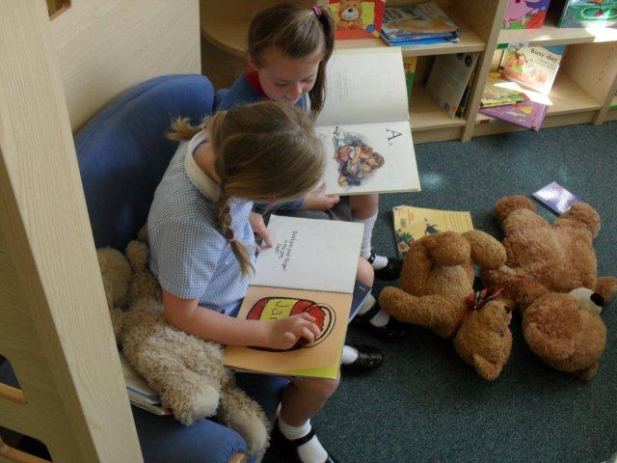
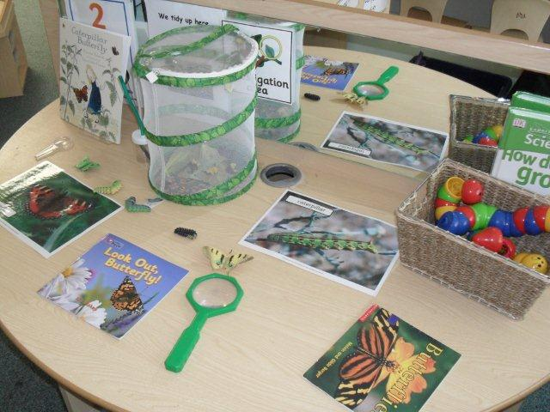
Staff change the indoor and outdoor environment to build on and adapt to the children’s interests and needs. Some decisions are part of initial planning, such as leaving a part of the garden area fallow for the children to dig and rake, but many changes come about because of what the staff see the children do. They noted, for example, that the children were not using several areas of provision as frequently as had been hoped. Prime examples indoors were the main home play area and the library which were used well by the Reception year children but less so by the Nursery children. Staff noticed that the Nursery children appeared unwilling to cross ‘an invisible divide’ from the Nursery base area to the library on the other side of the Foundation Stage Village. Similarly, they seemed reluctant to use the central play area. The decision to re-site the home play area to one side and to create additional, flexible thematic play areas has increased the involvement of Nursery and Reception children, and added to the complexity and quality of their play. The current theme of Travel and Transport has generated ‘Throston International Airport’, a garage and a camp site. These role-play areas are well visited by boys and girls alike and the play is typically long-lasting and imaginative. This is partly because of the good use of space and partly because of the high quality of resources; for example, at the airport there is a check-in area, lounge and steps into the aircraft. Children create and show passports, trundle suitcases and bags, and relax in the lounge where there are postcards and magazines. Similarly, the children were playing in a real bell tent with hurricane lamp, authentic barbecue and folding chairs. The good quality of the play is also due to the high quality of adult participation and interaction through comments, questions to provoke explanations and ideas, and demonstration, such as jotting down on a clip board at the garage a list of what the mechanics said they needed.
There has also been a major change to the library. Rather than have one well stocked area, several smaller reading areas have been created to encourage the use of information books alongside activities. The original library was made smaller and cosier, with floor cushions as well as chairs and settee. The number of books was reduced and each book was displayed with the front cover on show. Observations show that this area is now used more frequently, and for longer periods, by boys and girls. The Nursery children are using the story book area set up for them and there is always at least one area outdoors with a rug, den or seating area and a range of story and information books, usually related to the current theme.

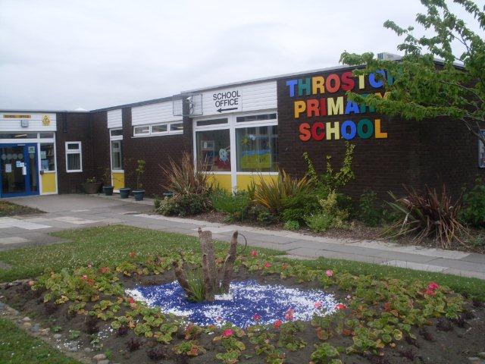
Provider background
Throston Primary School is in the heart of Throston Grange Estate, several miles west of Hartlepool, Teesside. There are about 400 pupils on roll with 59 children in the Reception year. Up to 39 Nursery children attend morning or afternoon sessions or both either at the start or end of the week. Few children speak English as an additional language. The Nursery and Reception classes are organised as a unit, the Foundation Stage Village, and share indoor and outdoor space. A children’s centre is also based in the school.
To view other good practice examples, go to: www.goodpractice.ofsted.gov.uk/

